**Magnetic Fields**

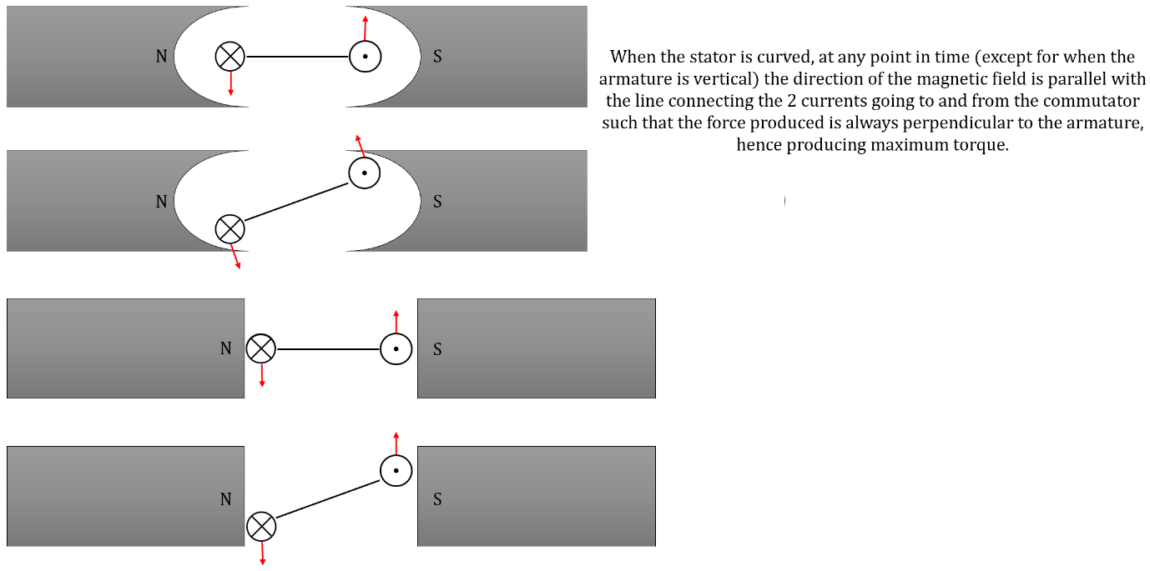

$$emf=-\frac{dΦ}{dt}$$

Back emf explanation:

As the coil in the motor rotates within the magnetic field from the stator, there's a change in magnetic flux in the coil. Hence, an emf is induced (Faraday's Law). This induced emf (back emf) opposes the driving emf, reducing its value until driving emf = back emf + applied voltage.

Counter torque explanation:

In a generator, as the current flows through the coil within the magnetic field from the stator, the interaction between the current in the coil and the magnetic field creates a force that opposes the motion and hence the torque of the coil due to conservation of energy. The counter torque increases until rotation occurs at a steady speed.

For alternating current, the RMS is equal to the value of the direct current that would produce the same average power in a circuit.

An electric current produces a magnetic field around the wire.

Force is perpendicular to the magnetic field and is due to the interaction between the magnetic field that the current flowing in the wire produces and the magnet’s magnetic field.

Where a conductor carrying an electric current is placed in a magnetic field, a force will result. This force is due to the interaction of the magnetic field created by the current in the wire with the magnetic field it’s placed in.

Force on a current-carrying wire placed perpendicular to a magnetic field:

F = Ilb where:

* F is force (N).
* I is current (A).
* l is the length of the current-carrying wire in the magnetic field (m).
* B is magnetic flux density (T).

Magnetic flux when the flux is perpendicular to the area:

ϕ = BA where:

* ϕ is magnetic flux (Wb).
* B is magnetic flux density (T).
* A is area (m2).

Magnetic flux density is much greater through near the poles of a magnet.

The direction of a magnetic field is indicated by the direction of the magnetic flux lines and its magnitude by the number of lines per unit area.

**Set 6**

**Q: Draw the magnetic field distribution for each of the following arrangements:**

**[a] Bar magnet.**

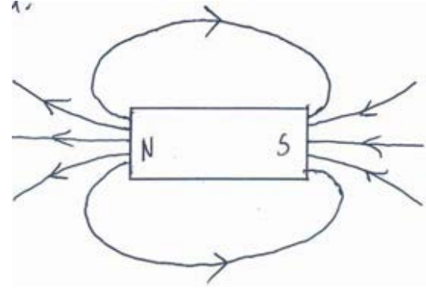

**[b] 2 parallel but separated bar magnets with opposite poles facing each other.**

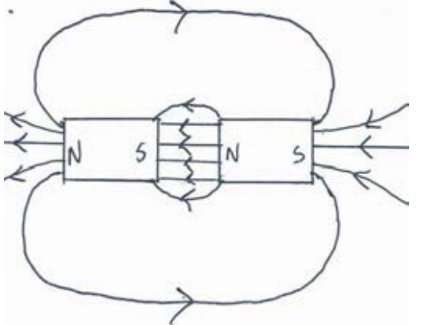

**[c] 2 parallel but separated bar magnets with like poles facing each other.**

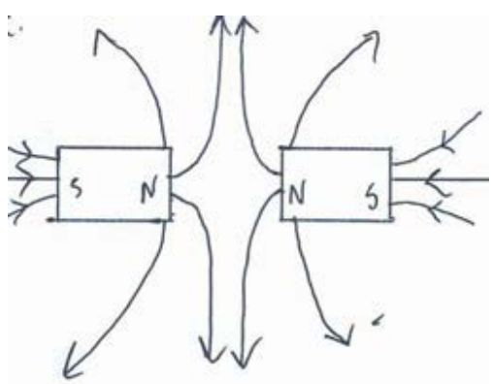

**[d] 2 bar magnets in line separated by 50mm with opposite poles facing and with a small iron washer placed midway between them.**

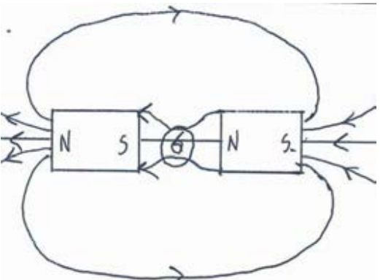

**Q: When plotting the magnetic field around a wire carrying a current, a student first ensured that there were no objects made of iron close to the wire. Explain.**

The presence of the ferromagnetic materials in the surroundings will alter the direction of the magnetic field lines. This is because ferromagnetic objects contain magnetic domains, making them more permeable to magnetic flux. This results in magnetic flux lines changing direction in order to pass through iron objects instead of passing through air or a vacuum.

**Q: A freely suspended current-carrying wire hangs perpendicularly. and parallel to a fixed similar conductor carrying an identical current.**

**[a] If both currents flow in the same direction, describe movement, if any, of the suspended wire. Support your answer with a diagram.**

If both wires carry current in the same direction they will experience a force of attraction towards each other.

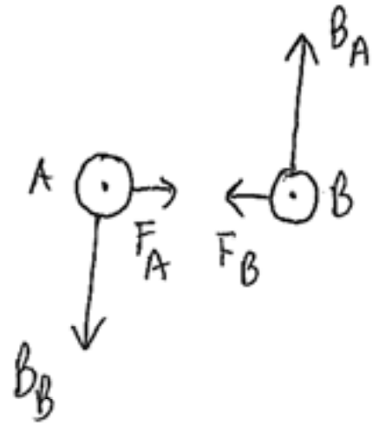

**[b] What will happen if the currents flow in the opposite direction?**

If the wires carry current in the opposite direction to each other then they will experience a force of repulsion away from each other.

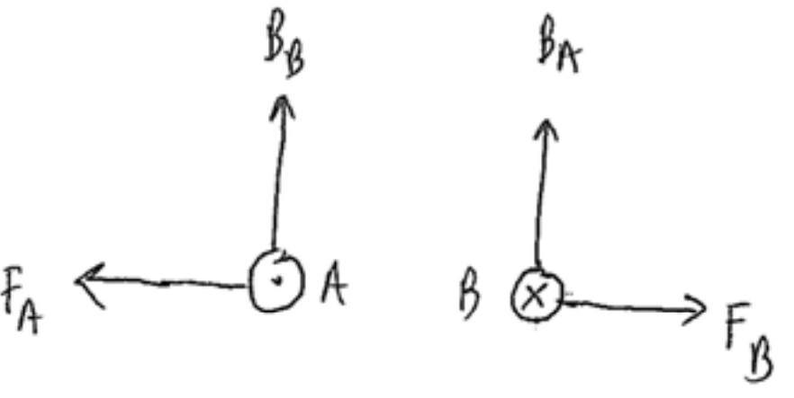

**Q: Draw a diagram of a solenoid and show the external magnetic field it produces when the driver turns the starter switch on.**

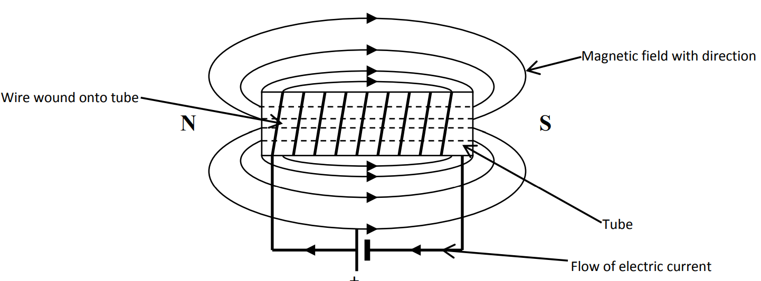

**Magnetic field pattern and show the relative strengths for:**

**[a] Current-carrying single wire.**

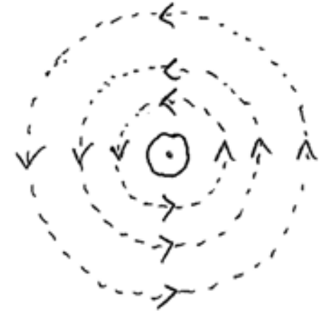

**[b] A current-carrying circular coil.**

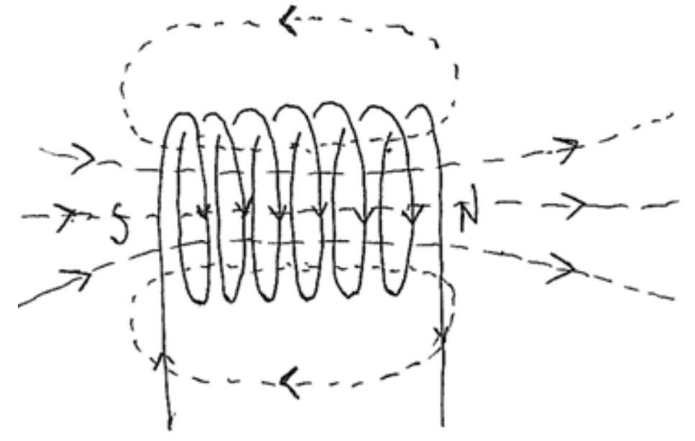

**Q: The instructions on magnetically-recorded media state that you shouldn’t put them next to electrical power cords. Explain.**

Electrical power cords produce magnetic fields when a current is flowing through them. The information is stored on the tapes as specific alignments of magnetic domains in the tape’s material. The cords‟ magnetic fields could alter the magnetic information stored on the tape by causing the domains on the magnetic tape to realign. This can result in the loss of the information.

**Direction of the force acting on the current-carrying wire**:

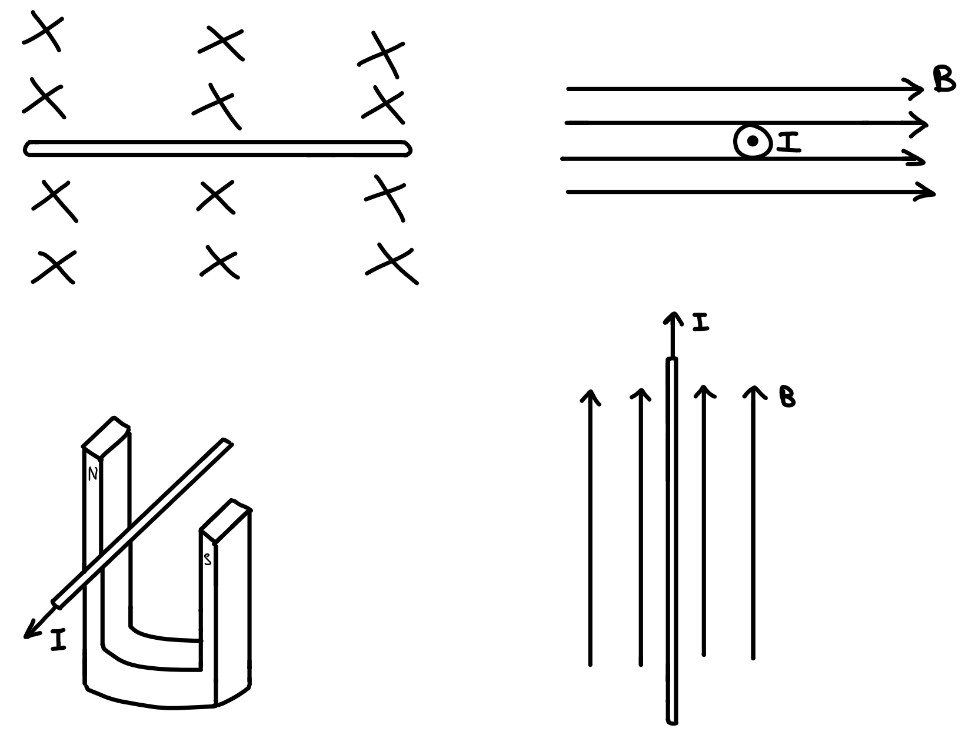



**Q: The following diagram represents a circuit for a simple electric doorbell. Explain why the bell sounds when you close the switch. Suggest how you can change the arrangement shown in the diagram to make the bell ring louder.**

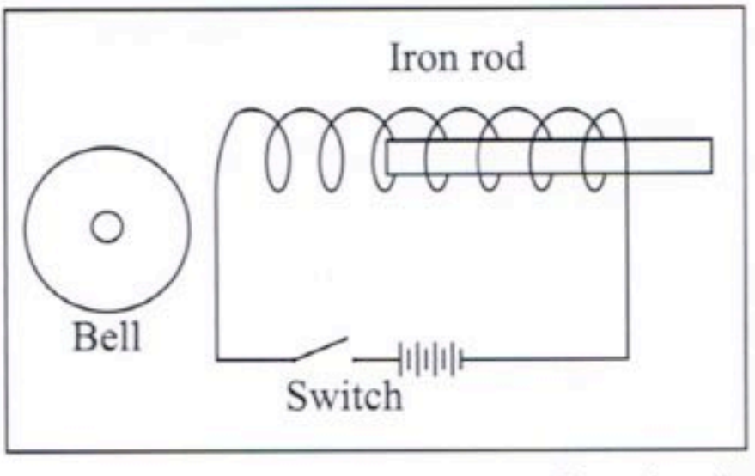

When the doorbell’s switch is closed, the current-carrying solenoid produces a magnetic field. This field magnetises the soft iron rod which is, therefore, attracted to the bell (which must be made of a ferromagnetic material). This force of attraction causes the rod to accelerate to the left. Even though the iron rod’s acceleration drops to zero when it is in the centre of the solenoid, its momentum continues its motion towards the left and, eventually, the rod strikes the bell.

The bell will ring louder if the iron rod strikes it with a greater force. The attractive force acting on the piece of soft iron can be increased by:

* Increasing the number of turns in the solenoid (increases “B‟).
* Increasing the amount of current that is flowing in the wire (also increases ”B‟).

**Q: Commercial electric motors may have up to 12 coils or “windings” with each located in a different position around the armature. Such motors produce a much more even torque than motors with fewer coils. Explain why this is so.**

The windings (armatures) experience the most torque when they are parallel to the magnetic field (the magnetic force experienced by the coil is at its maximum distance from the pivot of the coil in this position).

This torque reduces to zero as a winding rotates to a perpendicular position relative to the field (r = 0). In other words, the torque experienced by a single winding varies according to a sinusoidal function as it rotates – from a maximum to zero, and so on.

The 12 windings in a commercial motor are arranged at angles to each other within a 360º arc. A winding is only connected to the DC power supply when it is parallel to the magnetic field and experiencing maximum torque. Hence, at any given time, the motor is mostly experiencing maximum torque.

This means the torque produced by the motor remains relatively constant instead of varying between a maximum and zero torque as would be the case for a single armature.

**Q: A 75m long DC transmission cable stretches between 2 light towers in an east-west direction. Estimate the magnitude and direction of the force that the wire experiences because of the Earth’s magnetic field when a 40A current passes through it.**

Viewed from the south looking north:

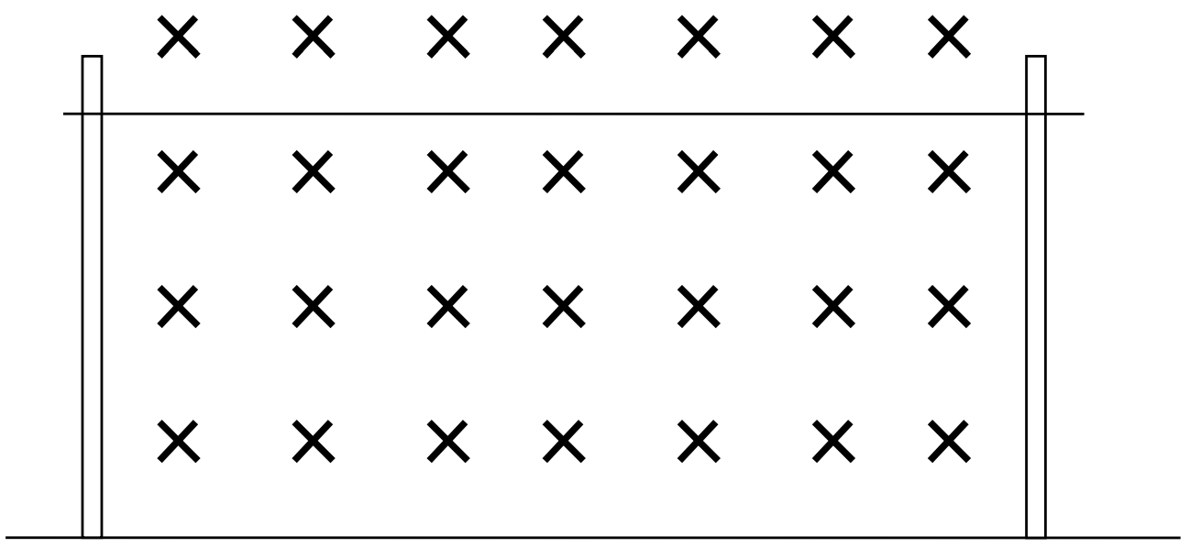

X represents Earth external magnetic field.

F = IlB = (40)(75)(5 x 10-5) = 0.150N

The direction of the force depends on the direction of the current:

* If conventional current flows to the west, then the magnetic force acts towards the bottom of the page.
* If conventional current flows to the east, then the magnetic force acts towards the top of the page.

**Q: The following diagram shows the design of an experimental electric train. It has the 2 poles of a magnet arranged on each side of a steel third rail in the middle of the track. The train has controls that can vary the direction and strength of current that passes between sliding contacts A and B.**

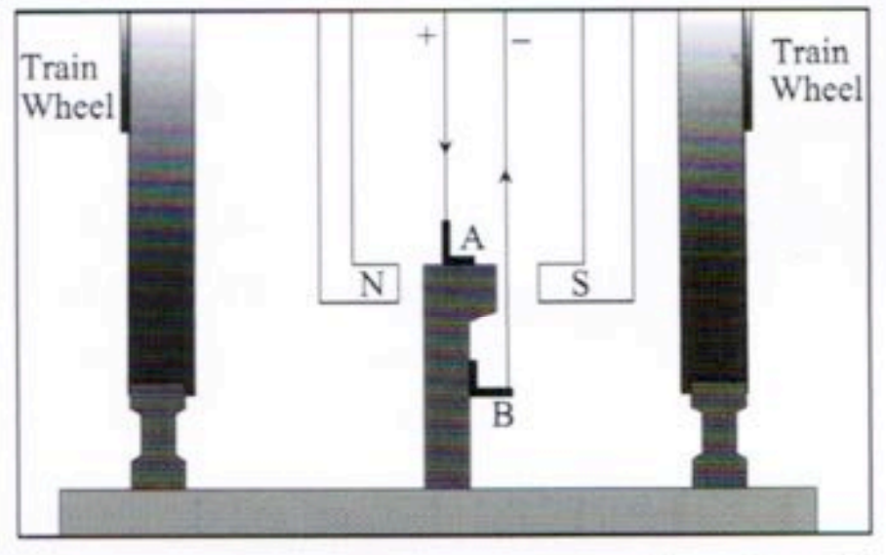

**[a] What’s the direction of the magnetic force that the magnet exerts on the third rail when current flows from A to B?**

Out of the page.

**[b] What’s the direction of the magnetic force that the rail exerts on the magnet?**

Due to Newton’s third law, into the page.

**[c] In what direction would the train move?**

The rails is in a fixed position on the earth, the train is not. Therefore, because the magnet is attached to the train, the train will move into the page.

**[d] Besides braking, the train could use some of its electric motor as generators t stop the train. What are 3 essential components of an electric motor?**

Armature, magnetic field and commutator.

**[e] How does an electric motor differ from an electric generator?**

The construction of each is very similar. There is, however, a difference in the inputs and outputs.

|  |  |  |  |
| --- | --- | --- | --- |
|  | Input: | Construction: | Output: |
| Generator | Motion | Slip rings | Electricity |
| Motor | Electricity | Commutator | Motion |

**[f] How would the train use its motor to brake?**

Applying the brakes would switch off the electric current that is supplied to the rail. The movement of the magnet past the charges in the rail induces an emf and an electric current in the rail. According to Lenz’s Law, the direction of this induced emf and current will oppose the change that produced it (i.e., the motion of the train). Hence, the train slows down.

**Q: A simple electric motor contains several coils of wire. Draw a diagram of a simple coil and sketch the magnetic field around it that’s produced when a current flows through the coil. Show the directions of both the current in the coil and magnetic field.**

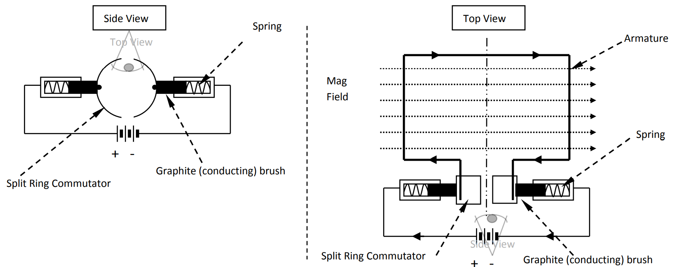

Continuous Ring Commutator - Alternating Current Motor

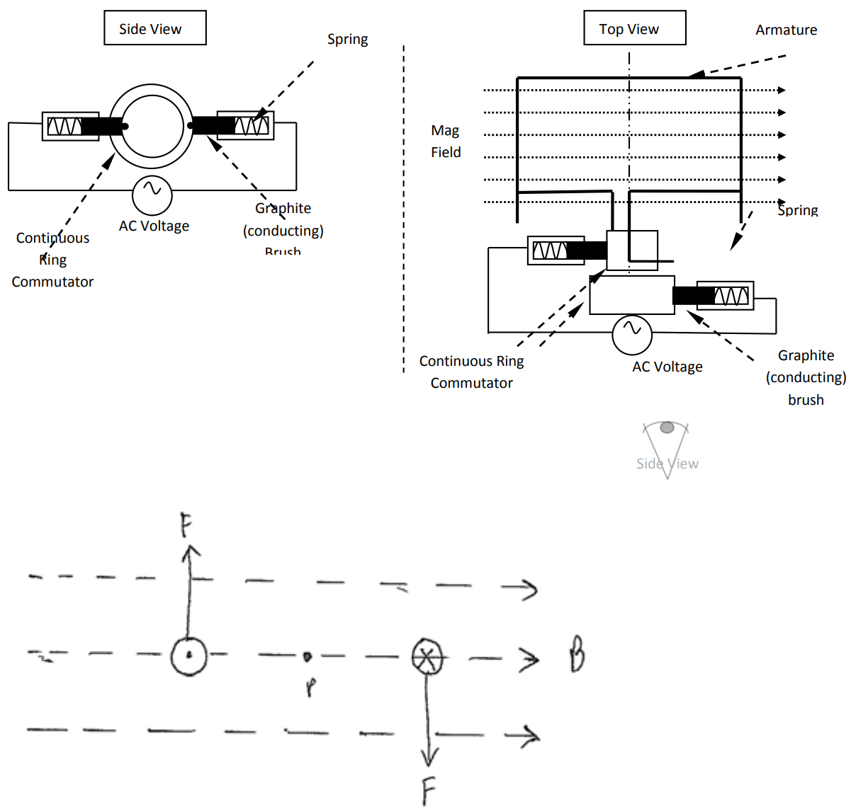

**Magnetic Induction**

An electric current produces a magnetic field and in certain circumstances a magnetic field can induce an electric current (induced current). This occurs whenever the magnetic field changes.

Electromagnetic induction: The production f an induced electric current in a conductor when there’s relative motion between the conductor and the magnetic flux.

2 ways of achieving electromagnetic induction:

1. Moving a magnet through a coil of wire.
2. Moving a conductor through a magnetic lux.

This generates a voltage (electromagnetic force (emf)) in the conductor.

emf: The greatest potential difference that an be generated by a particular source of electric current.

Faraday’s Law of Electromagnetic Induction: The magnitude of the induced emf in a coil is directly proportional to the rate of change of magnetic flux with that coil.

The induced emf across a conductor in the form of a coil or solenoid is equal to the rate at which the conductor cuts the magnetic flux.

emf = $–N\frac{Φ_{2} – Φ_{1}}{t}$ = $–\frac{NBA}{t}$

Where:

* N is number of turns in the coil.
* Φ2 – Φ1 = BA is change in magnetic flux (Wb).
* t is time over which the flux changes (s).
* emf is induced potential difference (V).

Induced current and potential difference in a moving conductor:

* When a conductor moves through a magnetic field, a force results on both the positive and negative charges within the metal.
* Although the positive charges usually can’t move, the free negative charges move to one end of the conductor, hence creating a potential difference/voltage between the 2 ends of the conductor.
* If these ends are joined to an external circuit, a current will flow.

emf of an AC generator:

The coil is a straight conductor cutting a magnetic field at 90° to the field.

emf = –NlvBsinθ

Where:

* θ is angle between v and B.
* l is length of the winding cutting the field.
* v is tangential velocity of the coil.
* B is strength of the magnetic field.

The negative sign is because its effect is in opposition to the force producing the motion.

For N windings turns on the coil:

emf = –NlvBsinθ for each side of the coil

emf = –2NlvBsinθ when both sides of the coil are considered.

emfmax = 2πNBA⊥f

Where:

* B is magnetic field strength or flux density (T).
* A is area of coil (m2).
* N is number of turns of coil.
* f is rotation frequency of coil (Hz).

The rms voltage is the equivalent DC voltage of the AC voltage of the same power.

Maximum emf: emfmax = –2NlvB

The emf produced will vary between zero and this maximum in a sinusoidal fashion. We use the rms value instead of the maximum value when dealing with alternating voltage:

emfmax =

The rms (effective) value of an alternating (time varying) sinusoidal waveform is the numerical value equivalent to the volts or amperes of DC that has the ability to produce the same power as that value in DC.

Lenz’s Law: The direction of an induced current is such as to always oppose the change that’s producing it.

This means that to keep a coil moving through a magnetic field, a resistive force must be overcome. In effect, the mechanical work done on the coil to keep it moving is converted to electrical energy in the form of the induced current.

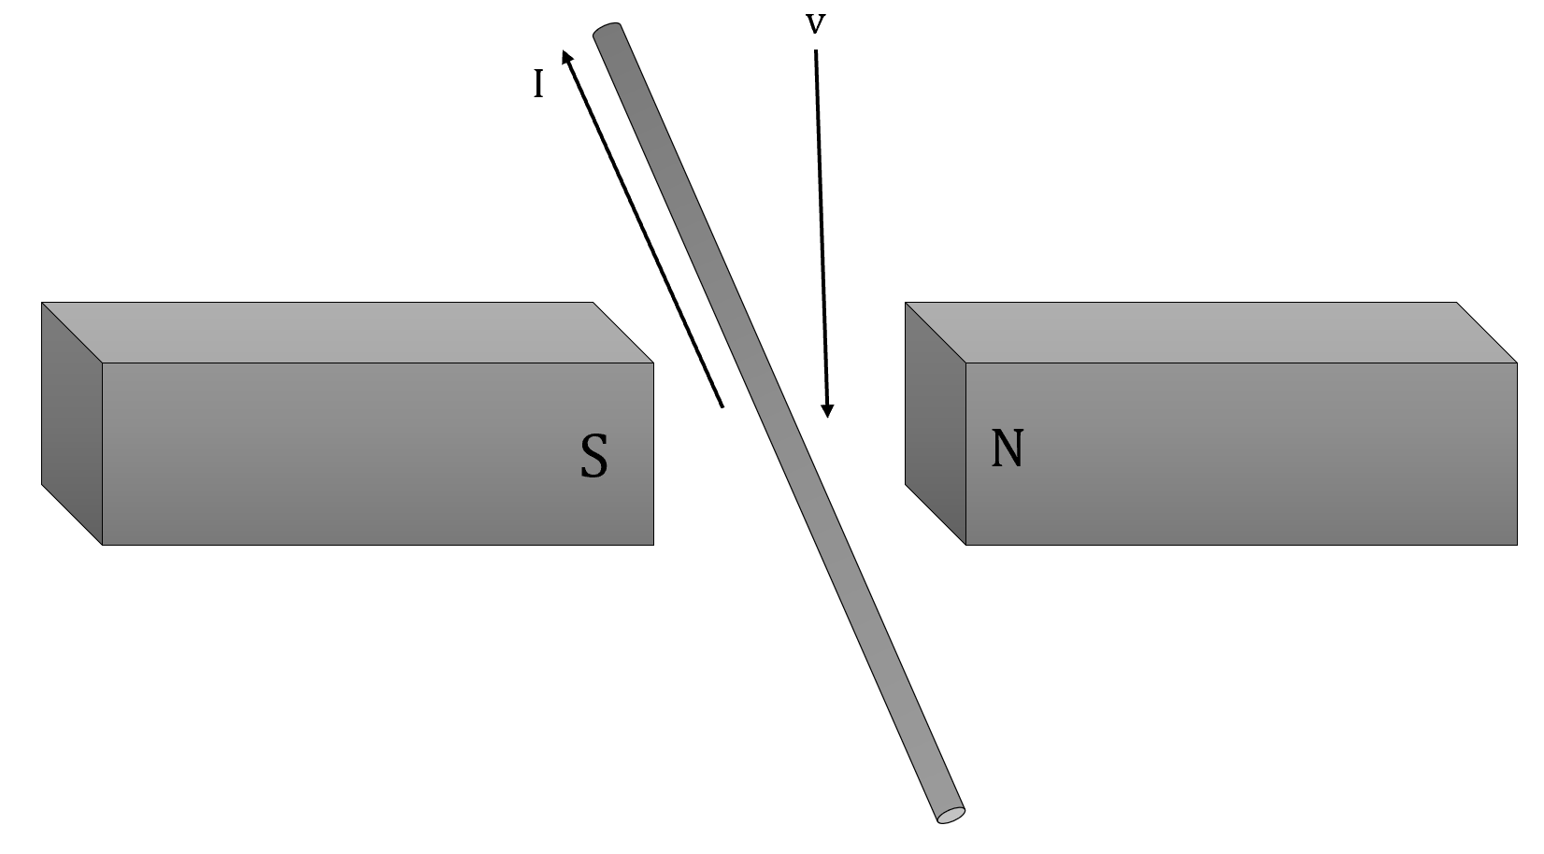

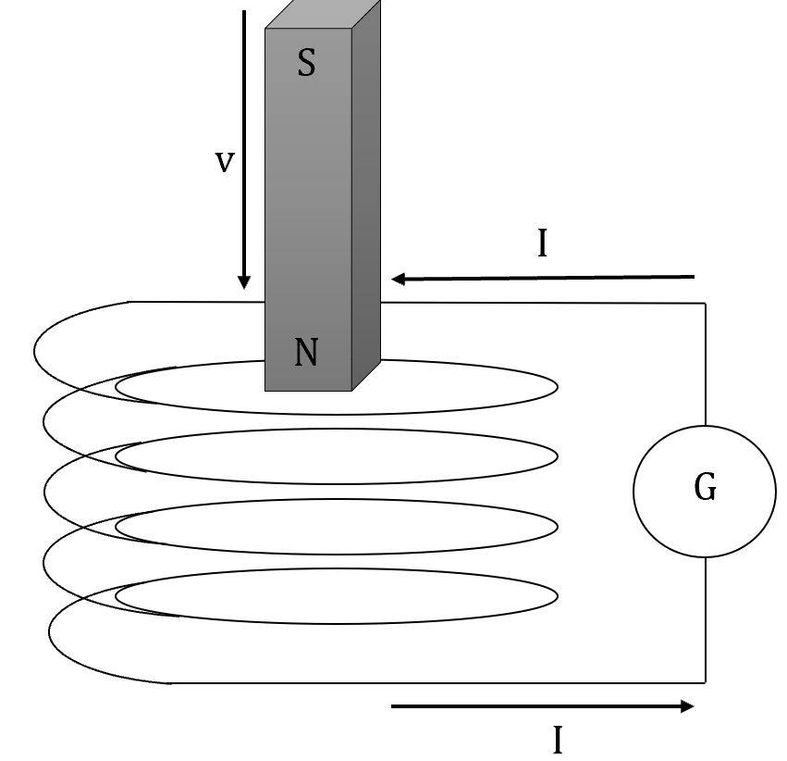

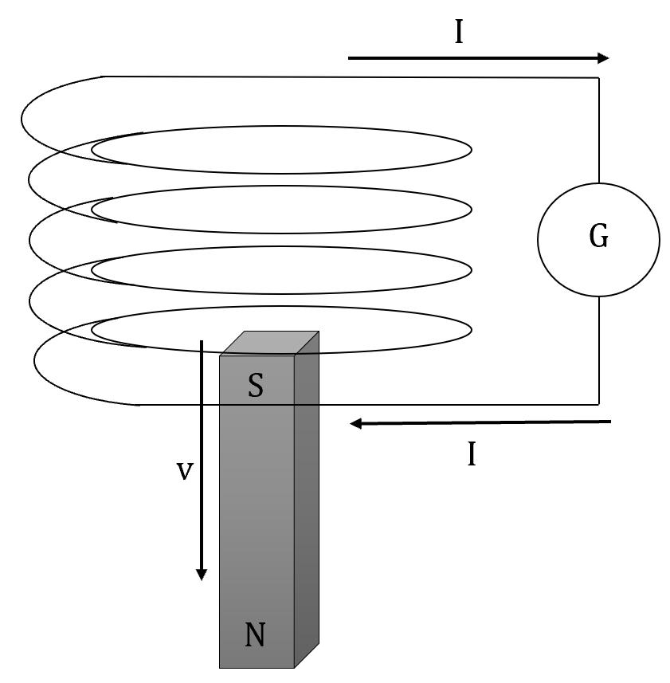

Induced emf in a rotating coil:

* If a coil is rotated in a magnetic field, an induced emf is produced since the magnetic flux enclosed within he coil is continually changing.
* As the coil is rotated, the amount of flux (ϕ) enclosed within the coil will change from zero to maximum repeatedly.
* This change in flux causes an emf to be induced, causing a current to flow.
* The change in flux is most rapid when the plane of the rotating coil is rarallel to the magnetic field.

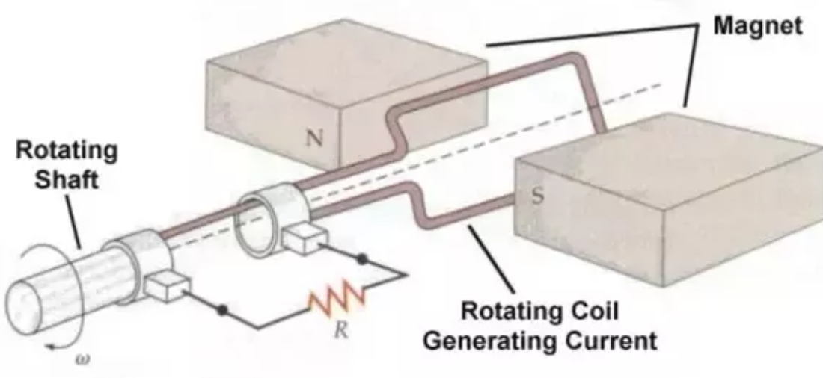

Electric power generators:

* The generator is designed to convert mechanical energy into electrical energy, the opposite to what occurs with an electrical motor.
* The AC generator has 2 slip rings for the transfer of current whereas the DC generator has a split ring instead.
* Commercial generators usually have field coils instead of permanent magnets and the rotating coil, which usually consists of a large number of turns, is wound onto a soft iron core called an armature.

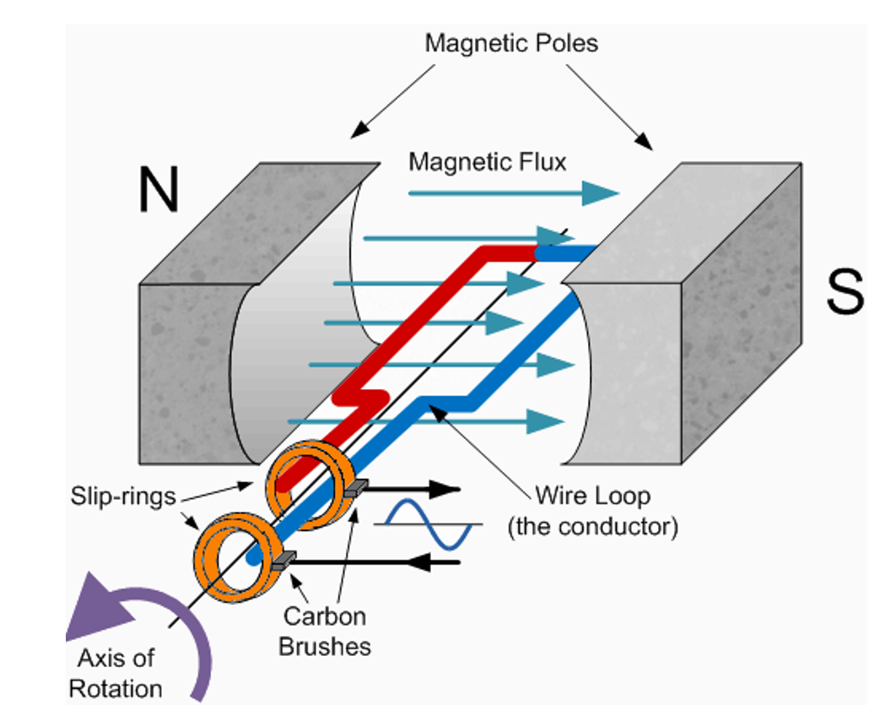

Simple AC generator:

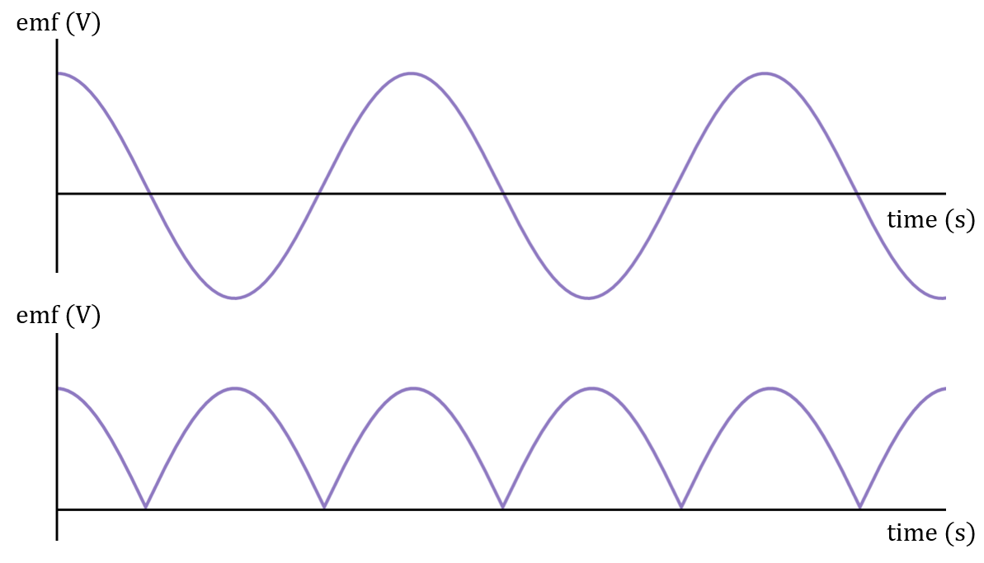

The use of 2 separate slip rings to transfer the current from the coil creates an alternating current output.

Simple DC generator:



The use of a split ring results in a current that reverses every half a cycle so that a DC output is produced.

Eddy currents:

* When a conductor is moving in a magnetic field, an emf is generated (Faraday’s Law).
* The result of this emf and the resistance of the conductor will be he production of swirling currents in the conductor.
* These currents are in closed loops and their direction will be such as to produce a net magnetic field in opposition to the one that caused them (Lenz’s Law).
* Such a field will oppose the original motion of the conductor. Currents like these that are set up in time-varying magnetic fields are called eddy currents.
* The work that these currents do (P=I2R) is dissipated as heat in the conductor. This process will continue for the duration that the time-varying magnetic field exists.
* The same effect will result if the conductor is held in place and the magnetic field is varied e.g., a stationary coil of wire connected to an AC supply as in a transformer.
* Laminations of metal are used to reduce the problem of the heating effects in the iron cores of electric motors and transformers.
* To reduce eddy currents and hence their heating effects, in transformer cores and the metal stators and armatures of motors, their coils are wound around a structure made from a number of thin iron (steel) sheets called laminations. Such laminations greatly disrupt the induction of eddy currents into the cores, hence reducing heating effects and greatly increasing the efficiency of the device.

Eddy current braking:

* The use of forces created by electromagnetic induction instead of friction to slow objects down.
* Eddy current brakes rely on the interaction between the magnetic field of an electromagnet and the opposing magnetic field produced in a moving conductor as a result of the eddy currents created in that conductor due to this relative motion.
* Efficient because the magnetic field associated with the eddy currents always opposes the magnetic field that produces it.
* Can use a linear or circular model depending on the motion of the device or its component parts.
* The linear model is used to slow down rollercoaster cars where the car is moving in a straight line and the metal track is stationary. Very high strength magnets are mounted on the straight section at the end of the track and metal plates are attached to the sides of the car so that they pass in very close proximity to the magnets. Large eddy currents are produced in the metal plates, resulting in the rapid slowing down of the car.
* The circular model requires one part of the braking system to be stationary and one to be rotating. A strong electromagnet replaces the brake pads and callipers with the rotating disc being similar but solid. Due to the large amount of heat produced in the metal disc because of the eddy currents, some sort of cooling system might be needed.

Regenerative braking:

* Recovers the kinetic energy lost in slowing down by converting it to a form that can be stored and reused later.
* Converting kinetic energy to electrical potential energy is the most common form of regenerative braking.
* Vehicles fitted with this system still need a conventional friction braking system to bring them to a complete stop as regenerative braking isn’t effective at slow speeds.
* They also need friction brakes fitted to the non-drive wheels otherwise they have no braking system on them.

**Set 7**

**Q: Explain why a TV set has vents in the walls of its casing.**

The television set is not 100 % efficient. Much of the energy that is lost is converted to heat. This heat must be vented to the surrounding or it will cause the internal components of the television to overheat.

**Q: A physics student inserted the north pole of a bar magnet into a coil that was connected to a galvanometer and noticed that the galvanometer needle moved to one side. When she withdrew the magnet from the coil she notices te needle moved to the opposite side of the galvanometer. Explain.**

Lenz’s Law: When the magnet is inserted a current is induced by the increasing field strength. The current is induced in such a direction as to oppose the field that created it. This means that the current that is induced creates its own magnetic field that repels (opposes) the increasing magnetic field strength.

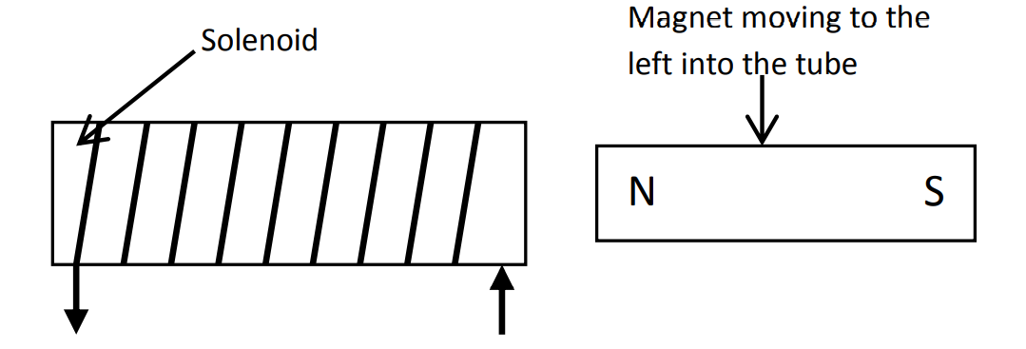

When the magnet is withdrawn a current is induced in the opposite direction to that above. This is because the external magnetic field is weakening. The current induced creates a magnetic field that attempts to attract the external magnet back.

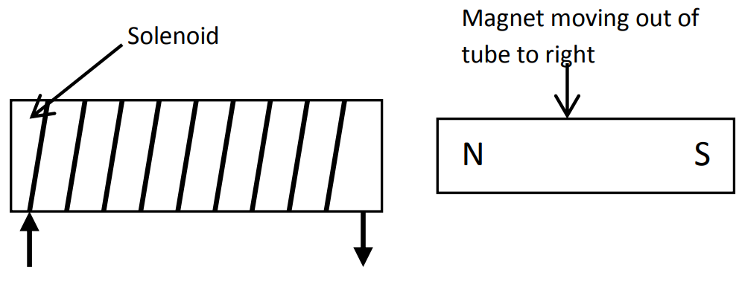

**Q: Referring to the following diagram:**

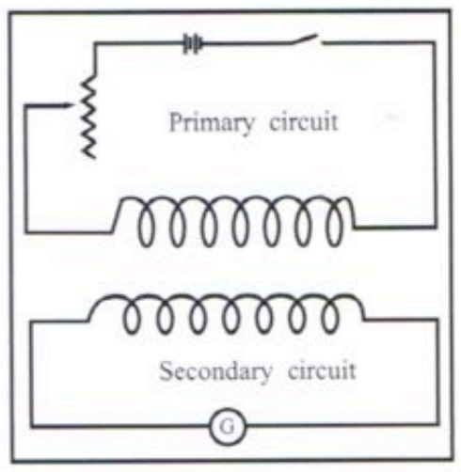

**[a] Explain why, when you close the switch in the primary circuit, you detect a transitory electric current in the secondary circuit.**

When the primary circuit closes, a current flows. The change from no current to a steady current, induces a magnetic field for that very short period of time. That magnetic field induces a current in the secondary. Since turning the switch on is a very quick change, the current noted in the secondary coil will only be induced for a very short time hence “transitory”.

**[b] Suggest at least 2 ways in which you can increase induced voltage in the secondary circuit.**

* Increase the voltage supplied to the primary.
* Decrease the switching time (difficult).
* Increase the ratio of the coils in the secondary to that in the primary.
* Link the primary and secondary coils using a hoop of soft iron.

**[c] Explain in which direction the current flows in the secondary circuit relative to the primary circuit.**

Lenz’s law: The current in the secondary is opposite that of the current in the primary when the switch is closed and the current increases. As the current is shown travelling from left to right through the primary coil in the diagram, the current through the secondary coil will be right to left.

**Q: An electrical engineer working on the design of a new electric train said “if the opposite of Lenz’s Law was true, the motors in this train would soon burn out”. Explain.**

Lenz’s law: Current induces a force. The force induces a current in opposite direction. This current opposes the original current and shows up as an increased resistance on the coil as the speed increases. This is also known as a back-emf. If as the motor spins the current induced was in the same direction as the original current, too much current would flow and this would result in the motor burning out. This would violate the law of conservation of energy.

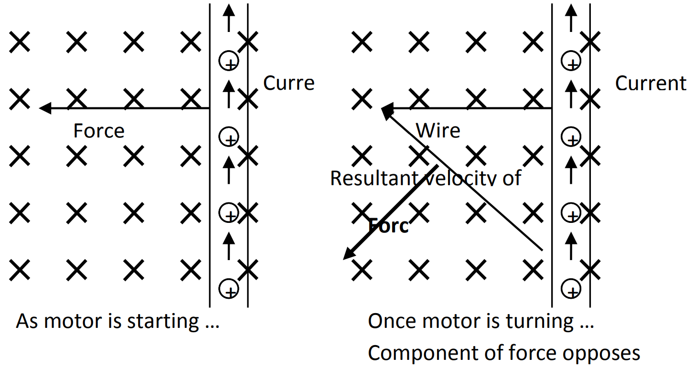

**Q: A train is travelling with a constant velocity of 80kmh-1 in an area where the vertical component of the Earth’s magnetic field is 36µT. If the train is travelling in a south-westerly direction, describe the force acting on an electron in this axle.**

If the earth’s magnetic field is out of the earth the force on the electrons will be south east. If the earth’s magnetic field is into the earth the force on the electrons will be north west.

**Q: Explain why a swinging pendulum made of an aluminium plate slows down when swinging between the poles of a strong horseshoe magnet.**

Lenz’s Law: As the plate approaches the magnet the field strength increases. This induces a current (eddy current) in the plate. The eddy current creates its own magnetic field in opposition to the strengthening original external magnetic field. This causes repulsion and slows the approach of the plate.

As the plate passes out the other side the external magnetic field experienced by the plate is decreasing in strength. This induces a current in the plate. The current creates its own magnetic field in support of the weakening external magnetic field. This attracts the plate and slows its movement away from the magnet.

The slowing on approach and slowing on exit causes the swing of the plate to be damped and so the pendulum comes to a stop sooner.

**Q: A simple generator contains a square armature coil of side lengths 200mm by 200mm. The coil contains 300 turns of copper wire and rotates at 60 evolutions per second in a uniform magnetic field. At what point in its rotation is the peak voltage produced? At what point is the voltage zero?**

Maximum voltage is when wires cut across the flux.

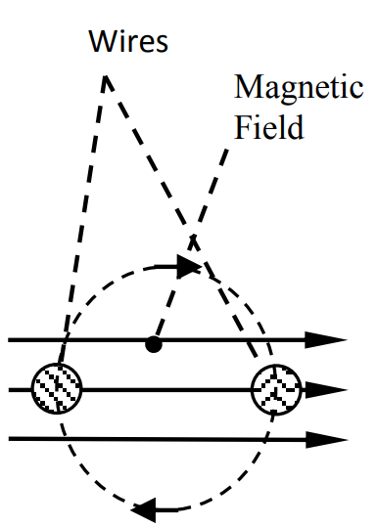

Minimum voltage is when wires move parallel with the flux.

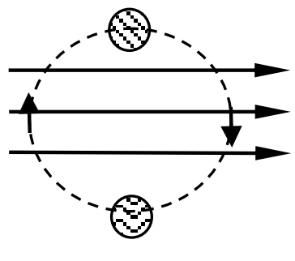

**Q: A moving coil meter has a coil that’s wound on either a plastic or a metal former. These 2 types of meters behave completely differently when connected in a circuit. Explain how and why they would behave differently.**

The metal will usually be of a ferromagnetic type. The current through the coil magnetises the iron, and the field of the magnetised material will add to the field produced by the coil. The core can increase the magnetic field of a coil by many times over what it would be without the core, resulting in a larger deflection for any given current.

**Q: Each of the turn coils in an AC generator is rectangular. The rotor the coils are wound on rotates between the curved poles of a stator where’s a uniform magnetic field. What’s the advantage of the poles of the stator being curved?**

Curved poles keeps more of the coil more perpendicular to the magnetic field for a greater amount of time.

**Electrical Energy & Power**

Electrical energy can be transformed into mechanical work useful in electrical work or thermal energy.

P = = VI = = I2R

A power transformer functions on AC and changes potential difference from one value to another with minimal loss of energy, It consists of 2 coils of wire, called the primary coil and secondary coil, wound on the same soft iron ore.

A changing magnetic field will create an emf in a nearby coil. Transformers make use of this by creating a continually changing magnetic field in a primary coil which in turn creates a changing emf in a secondary coil.

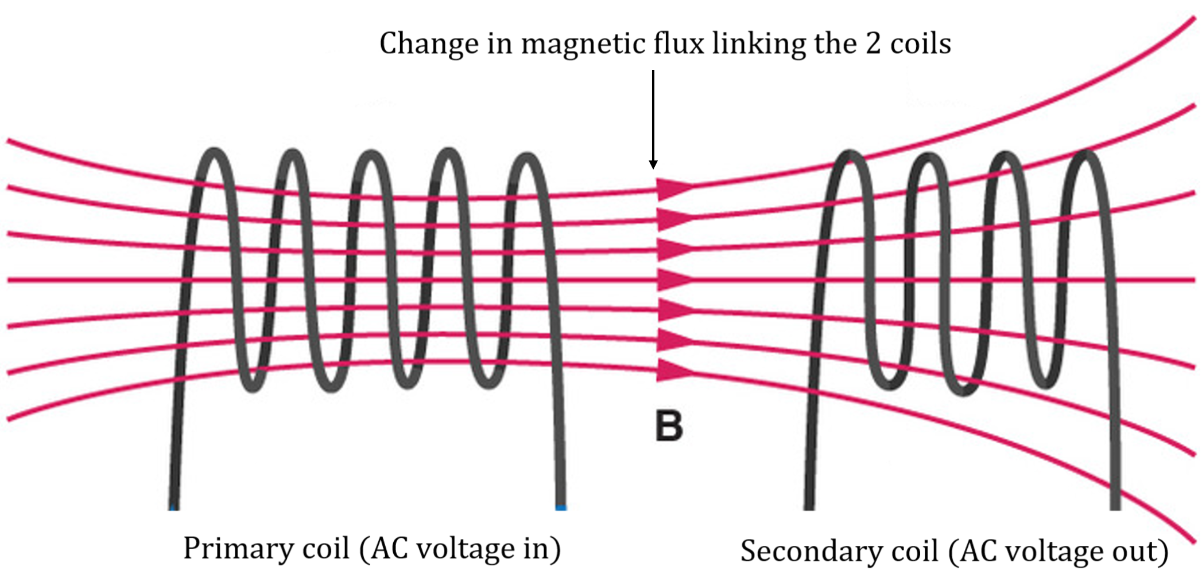

If the current in the primary coil shown is increasing steadily, a constant negative current is induced in the secondary coil. If the current in the primary coil is steady then no current exists in the secondary coil.

The purpose of transformers is to allow the efficient change of AC voltage. The use of laminated soft iron core, onto which both primary and secondary coils are wound, increases the efficiency of a transformer.

* The iron core increases the flux link between the coils.
* The laminations reduce eddy currents and minimise energy lost in the form of heat.

Ideal (100% efficient) transformer:

Electric power (primary) = electric power (secondary)

VpIp = VsIs

Turns ratio of a transformer: $\frac{N_{p}}{N_{s}}$

Ideal transformer: $\frac{N_{p}}{N_{s}}$ = $\frac{V_{p}}{V_{s}}$

**Set 8**

**Q: While performing a laboratory investigation on the structure of a step-down transformer, a student noticed that the wire in one of the coils was thicker than the wires in the other coil. Does the thicker coil belong to the primary coil or the secondary coil? Explain.**

The thicker wire is on the low voltage side of the transformer. In a step down transformer this is on the secondary side. If the power out of the transformer is similar to the power in, then based on P = VI, if the voltage drops on the secondary side then the current must increase. This increase of current flow results in a heating effect in the secondary wire due to the resistance of the wire. If the wire is made thicker then the resistance of the wire is reduced (R = $\frac{pl}{A}$).

**Q: The following diagram shows a simplified view of a transformer without its metal core plates. It consists of 2 coils of wire, one inside the other. If the current in the outer coil is moving anticlockwise and is increasing, explain how you’d determine the direction of the current induced in the inner coil.**

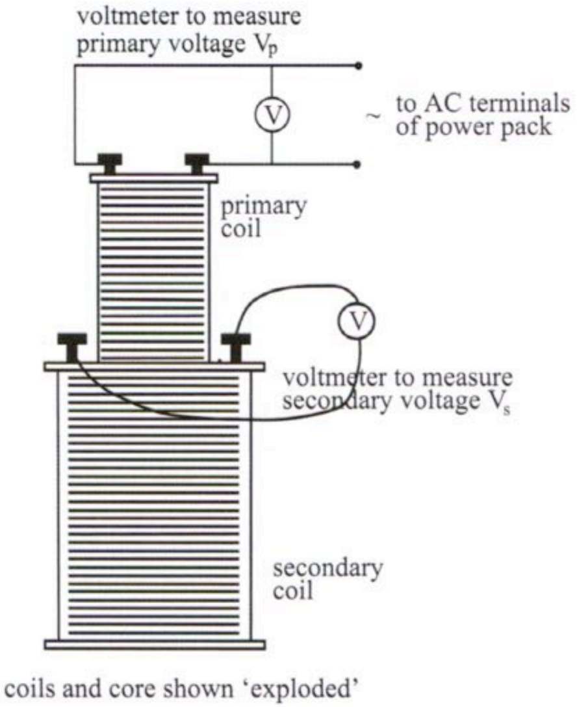

Current in the outer coil is anti-clockwise and increasing at a constant rate. By Len’s Law the current on the inner coil is clockwise and steady. Primary current created a strengthening field. Strengthening field induces current in the secondary. The magnetic field created by the secondary current is in such a direction as to oppose the change that created it.

**Q: A car engine needs around 1kW to start it. The starter motor supplies this power. The starter motor is 80% efficient and it runs on a 12V battery. In what way is the diameter of the copper wire that joins the battery to the starter motor quite different to the other electrical wires in the car? Why?**

The wires connecting the battery to the starter motor are thicker than the other wires. This is because the current supplied to the starter motor is large Since Ploss = I2Rwire, when the resistance in the wire is large, the power loss will be large. By using a thicker wire, the resistance of the wire is decreased and hence the power losses are decreased.

**Q: An electricity sub-station is a transformer converting the higher voltages from direct supply from the power station to lower voltage in preparation for distributing out to the local area. Power from the power station is supplied at high voltages to reduce the supply current and hence power losses.**

**[a] Suggest some reasons why an electricity wouldn’t use the same substation to supply electricity to both an electric train system** and to nearby houses.

* Train systems operate at higher voltages than neighbourhood houses.
* The power demand of a train is near zero when stationary, very large when accelerating and medium when running at a constant velocity. These fluctuations in demand will result in fluctuations in the amount of power available to houses also connected to the substation.

**[b] Why does the electricity utility step up the voltage before it’s transmitted to the train station?**

The voltage is stepped up in order to minimise the current flowing in the high tension (high voltage) wires. By decreasing the current, it decreases the power loss in the transmission line.

**Q: Electricity utility usually transmits energy at very high voltages. However, engineers have worked out that voltages over 1000V are uneconomical and have an impact on the environment. Explain.**

Transmission pylons have to be high enough above the ground to reduce the effect of the magnetic field induced by the power lines. These would otherwise induce currents in metallic objects in the surroundings (houses, cars etc). Eventually the cost of the larger pylons outweighs the cost associated with the power loss.

**Q: An electric motor in a goods lift needs a minimum voltage of 405V to operate. The cable supplying power to the motor comes from a transformer. How would you change this arrangement to allow the motor to work for a larger distance from the transformer?**

The power loss can be reduced by reducing the current in the wire. Changing the transformer ratios to increase output voltage will decrease the output current and allow the motor to work at a larger distance.

**Q: A portable generator can provide 5kW of electrical power. A petrol engine drives the generator. The generator is 80% efficient. Explain where you think the power losses occur in the generator.**

Heat losses in converting the chemical potential energy in the fuel to mechanical energy in the generator, heat energy losses due to friction in bearings, resistance in the windings of the armature. Sound.

**Q: Electric motors, fluorescent lighting systems and arc wielding equipment all use some of the electrical energy they consume to create magnetic fields. If you have several such devices operating at your house, what effect would this have:**

**[a] On the voltage available to other devices on your property?**

The voltage available to other devices should remain at 240 V. If a lot of current is supplied to one device, for example the electric motors or arc welding equipment, the mains may difficulty supplying sufficient power so some dimming of lights or reduction in speed of the motor may occur (brown out).

**[b] On the temperature pf the supply lines to your property.**

As more power is supplied to a house an increasing amount of current has to flow in the supply lines to the house. This will cause heating of the supply lines according to Ploss = I2Rlines.

**[c] On the brightness of electric lights on your property.**

If excessive current is drawn by one device, insufficient power may be available for the other appliances running including the lights. The lights may dim.

There are four main causes of inefficiency in transformers:

Resistance of the windings.

Flux leakage – poor design may mean not all of the flux from the primary coil is linked to the secondary coil.

Eddy currents in the iron core.

Hysteresis – Constant reversing of the magnetic field in the core expends energy.

**Q: A transformer designed to work on a primary input of 240V rms has 2 independent sets of secondary windings. One of these is step down and delivers 6.3V rms at 8A to the heating element of the electron gun of a CRT and the other is a step up that delivers 2500V rms at 15mA to the velocity filter of that same electron gun. How would the wires in the 2 secondary coils of a transformer differ from each other? Explain.**

The coils in the step up transformer would use considerably finer wire than the step down. As the current is comparably smaller, power losses are minimised. The step down transformer should have thicker wire in order to minimise resistive power losses with a higher current.

**Q: A simple motor is connected to a battery pack and the current through it is measured using a digital ammeter. The results obtained were plotted against time for the first few seconds and the following graph was obtained. Explain the shape of this graph.**

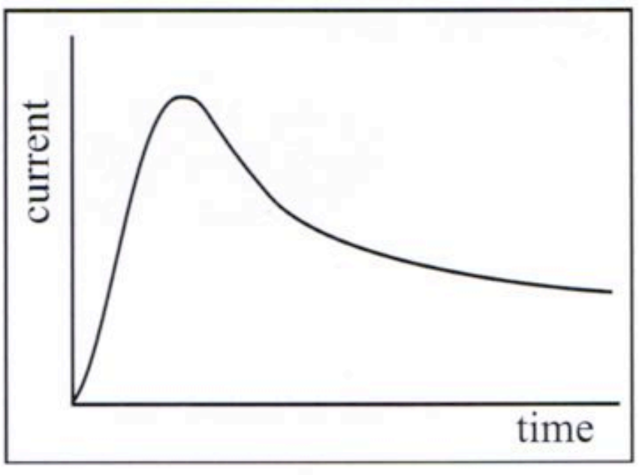

Initially, the motor is not turning and there is no induced back emf. The current is very high. As the motor spins up to operating speed, the back emf increases and the current being drawn reduces.

**Charged Particles in an Electric Field**

Electric field: The region around a charge or group of charges that can influence another charge placed in that region.

The magnitude of an electric field is the size of the force it causes on a charge placed at a point in the electric field.

E = $\frac{F}{q}$

Where:

* E is electric field strength (NC-1 or Vm-1).
* F is force acting on a small charge (N).
* q is charge (C).

If 2 objects of different materials are rubbed together, static electricity results. The friction between the objects causes a transfer of electrons from one to the other, resulting in the bodies acquiring equal and opposite static charges.

2 oppositely charged parallel plates that are close together have an electric field between them that’s uniform, except near the edges. A charged particle in the uniform electric field between the plates experiences a force and therefore moves.

Parallel plates:

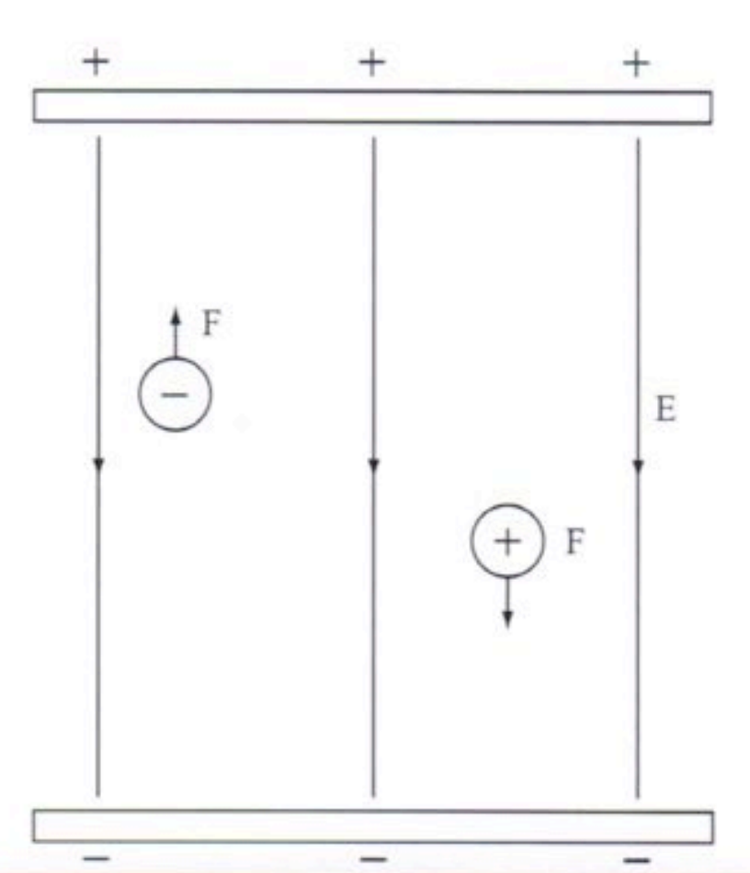

Work done by the electric field in moving the charge a distance parallel to the field:

W = Fs = Vq = Eqd

Where:

* W is work done (J).
* E is electric field strength (NC-1 or Vm-1).
* q is charge on the particle (C).
* d is distance the charged particle moves (m).
* V is potential difference through which the charged particle is moved.

F = $\frac{1}{4πE_{0}}\frac{q_{1}q_{2}}{r^{2}}$

Where:

* F is force between point charged (N).
* q1 is charge on body 1 (C).
* q2 is charge on body 2 (C).
* r is distance between the 2 charged (m).
* ℰ0 is the electronic constant (permittivity of free space (8.85 x 10-12Fm-1)).

Electric fields:

* An electric field exists at a point if a charge placed at that point experiences a force.
* An electric field is a vector quantity.
* The direction of an electric field is taken as the direction that a positively charged body would move if placed at that point.
* An electric field is represented by lines of force/flux lines.

Electric fields between charges and plates:

Where there’s more than a single point charge, the resulting electric field distribution will be the vector sum of the individual fields at any particular point.

Electric fields in a metal conductor:

An electric field will cause charges to move if they’re free to do so e.g., if a battery is connected to the ends of a conductor, the resulting electrical field will cause a net flow of electrons. The electrons will move in the opposite direction to the field.

Electric fields cause a net flow of charge in a conductor.

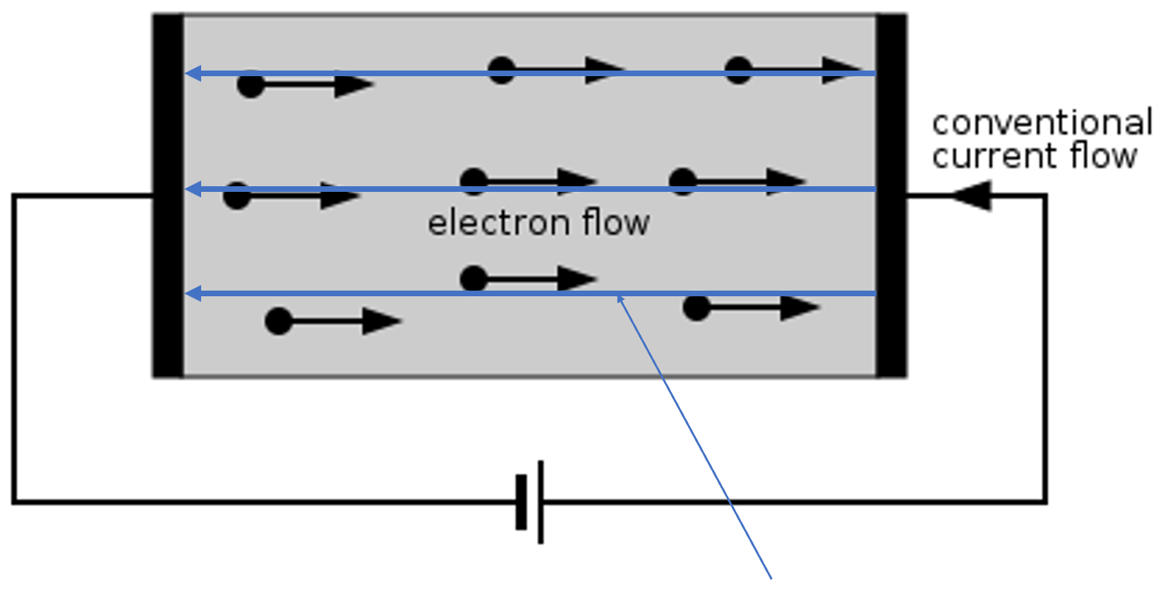

Direction of electric field inside conductor

Electric potential:

* The work done in bringing a distant positive charge to point B is stored as electrical potential.
* If the charge is moved to point A, it will acquire a higher electrical potential energy to overcome the force of repulsion.
* Points A and B are points at different electrical potential. Point A has a higher potential than point B.

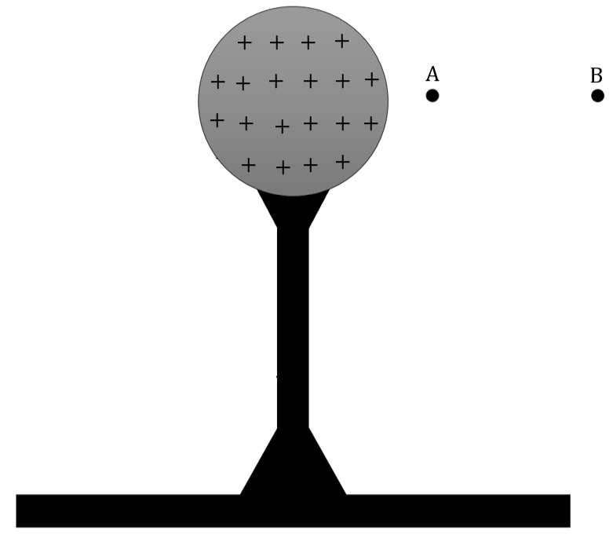

Electrical potential difference:

* Moving a charge in an electric field involves work (energy) and hence a change in electrical potential energy. A potential difference of 1V exists between 2 points if a charge of 1C moving between those points has its electrical potential energy changed by 1J.
* Voltage/emf is a measure of the energy supplied to each coulomb of charge passing through it.

Conductor: Any material that contains electric charges that are free to move.

Electric current: The rate of flow of electric charges.

**Set 9**

**Q: An electron enters an electric field perpendicular to the field.**

**[a] Draw a diagram to represent the electric field between the charged plates.**

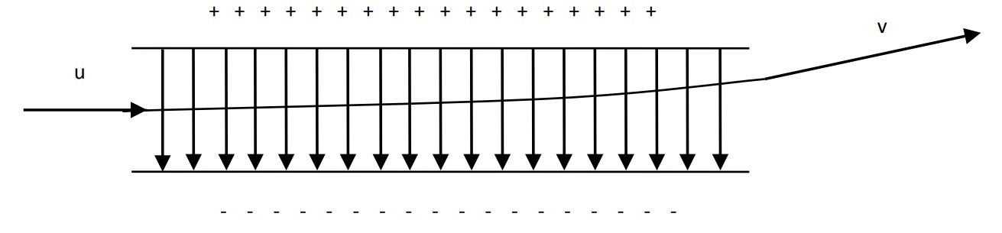

**[b] Compare the velocity of the electron as it leaves the electric field with its velocity on entering the electric field.**

Initial velocity (u) is purely to the right Final velocity (v) is the same to the right but also contains a component towards the top of the page. This component has been provided by the electric field.

Time for which the electric field acts = the time for which the charge is between the plates.

t = $\frac{0.03}{2.9 x {10}^{7}}$ = 1.03 x 10-9s

Time for which the electric field acts = the time for which the charge is between the plates.

Eq =

2.5 x 104 x 1.6 x 10-19 = → v = 4.54 x 106ms-1 in the original direction.

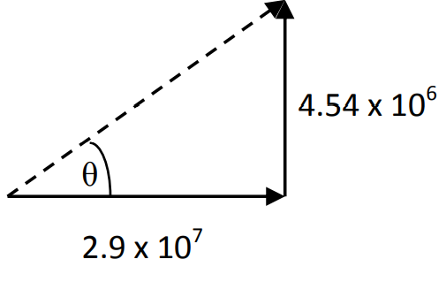

R = = 2.94 x 107ms-1

θ = tan-1() = 8.90°

R = 2.94 x 107ms-1 8.90° to the original direction

**[c] Explain why the electron experiences a change in its velocity.**

The electron experiences a force which causes an acceleration towards the positive plate.

**[d] Explain how a CRT uses the deflection of electrons by such parallel plates.**

Electrons are deflected toward a particular point on the screen. The electrons on striking the screen cause a chemical on the screen to fluoresce. This creates an image on the screen.

**Q: Explain why the radio frequency component of a radio or TV set is totally enclosed in a hollow aluminium box.**

This is done to remove the interference of external (unwanted) radio signals and other EMR. The box acts as a faraday cage. The only signal that can get into the box is the one that is passed down the TV aerial and is able to pass through the circuitry that selects the radio or TV channel. All other signals are excluded.

**Q: When the driver got out of a car after stopping it at the side of a dry gravel road, the driver’s polyester shirt attracted dust particles. Explain.**

The shirt has a static charge on it from the outer surface of the car. The dust particles became charged by induction and, hence, were opposite that of those on the shirt and so the dust was attracted.

**Q: Many coal-fired electrical power stations have electrostatic precipitators inside their chimney stacks. Explain:**

**[a] How an electrostatic precipitator works.**

An electrostatic precipitator uses a static charge to attract the dust and soot out of the smoke and gasses passing up a chimney or smokestack. This leave gases that come out the end of the chimney clear of dust and soot.

**[b] Why a power company would install one.**

A power company would install one to meet pollution regulations governing the type of waste that it can pollute the environment with.

**Q: To demonstrate the magnitude of the electric field produced by a Van de Graaf generator, an investigator uses a fluorescent tube. When she held the tube so it pointed towards the generator, it produced light and flickered. When she held the tube perpendicular to the generator, it produced no light. Explain.**

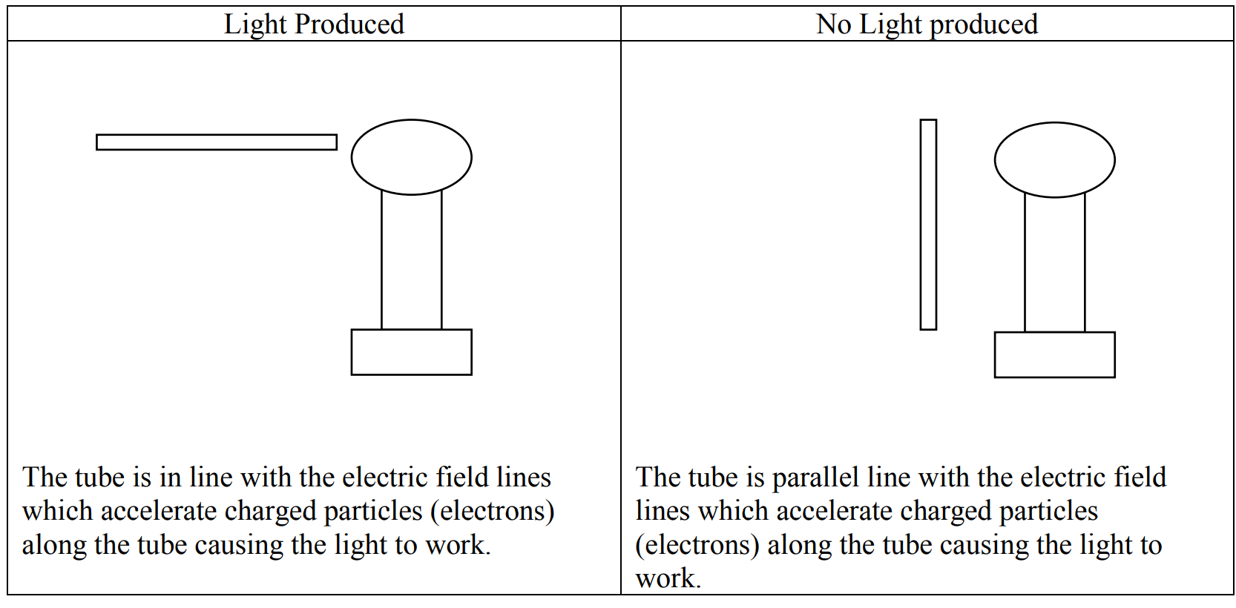

**Q: An initially stationary electron is accelerated by an electric field.**

[a] Draw a labelled diagram showing the direction of the field and the direction of the electron’s final velocity.

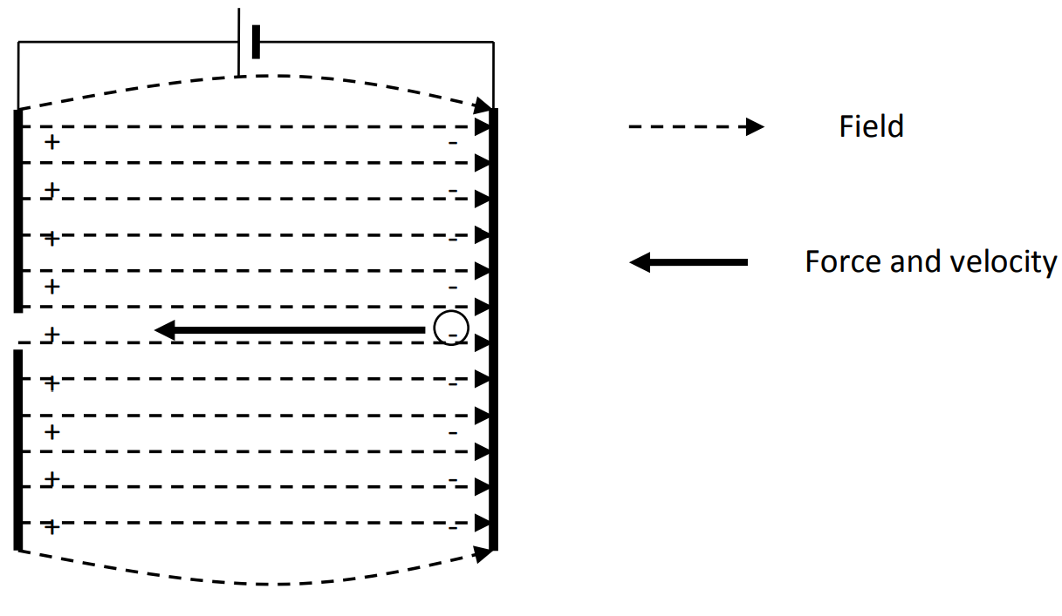

**[b] If the same field had accelerated a proton instead of an electron:**

**[i] Draw a labelled diagram showing the direction of the field and the direction of the proton’s final velocity.**

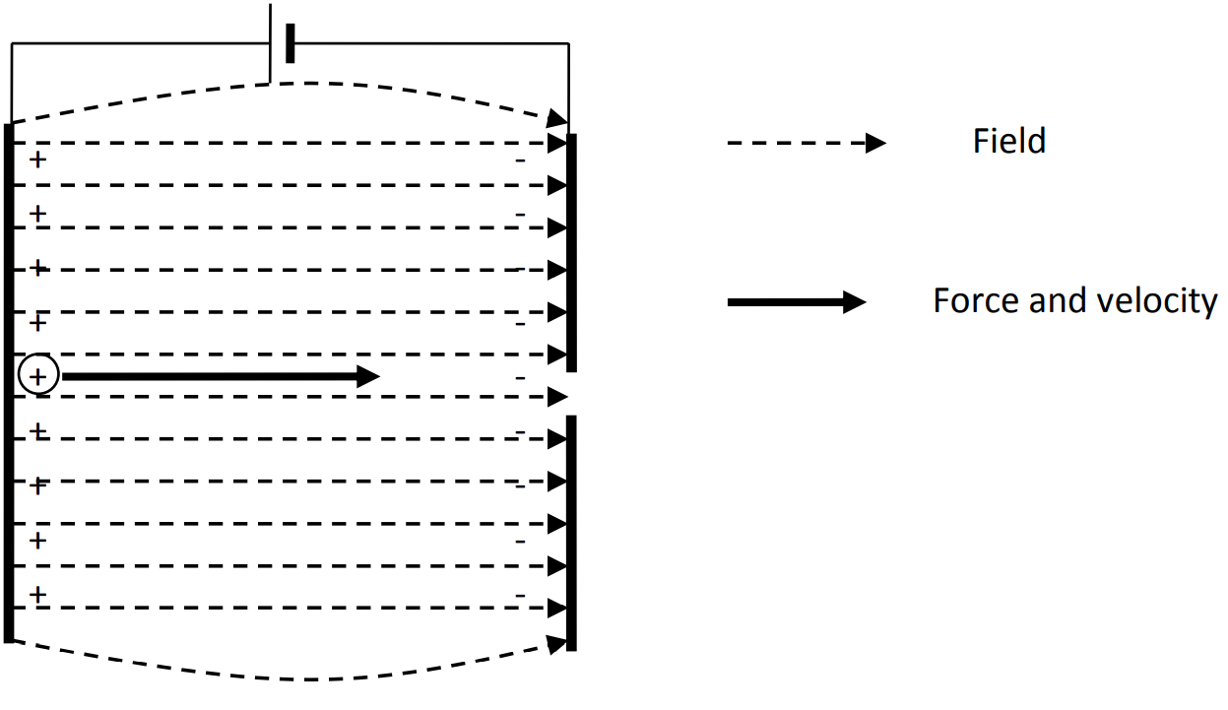

**[ii] Would the proton have gained more than, the same as or less than the kinetic energy gained by the electron?**

Same kinetic energy or work as before because charge has not changed magnitude.

**[iii] Would the magnitude of the proton’s final velocity be greater than the same as or less than the final velocity of the electron?**

Final velocity of proton will be less than that of the electron because it has more mass. As m increases v2 decreases.

**Q: An electron in a CRT was accelerated from the emitting filament to a plate through a potential difference of 4000V.**

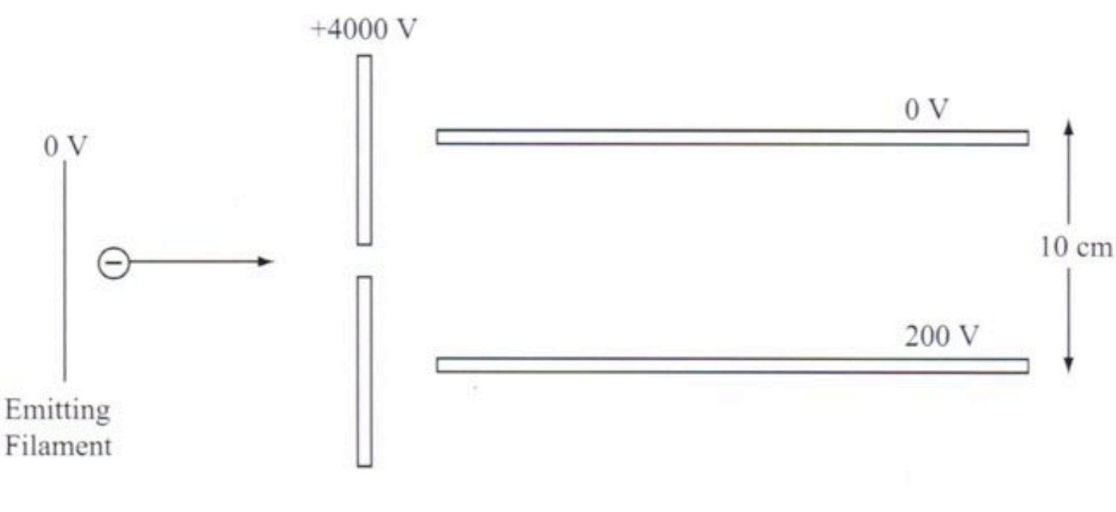

**Draw a diagram showing the plates, the electric field between them and the path of the electron assuming that it didn’t contact either plate during its passage.**

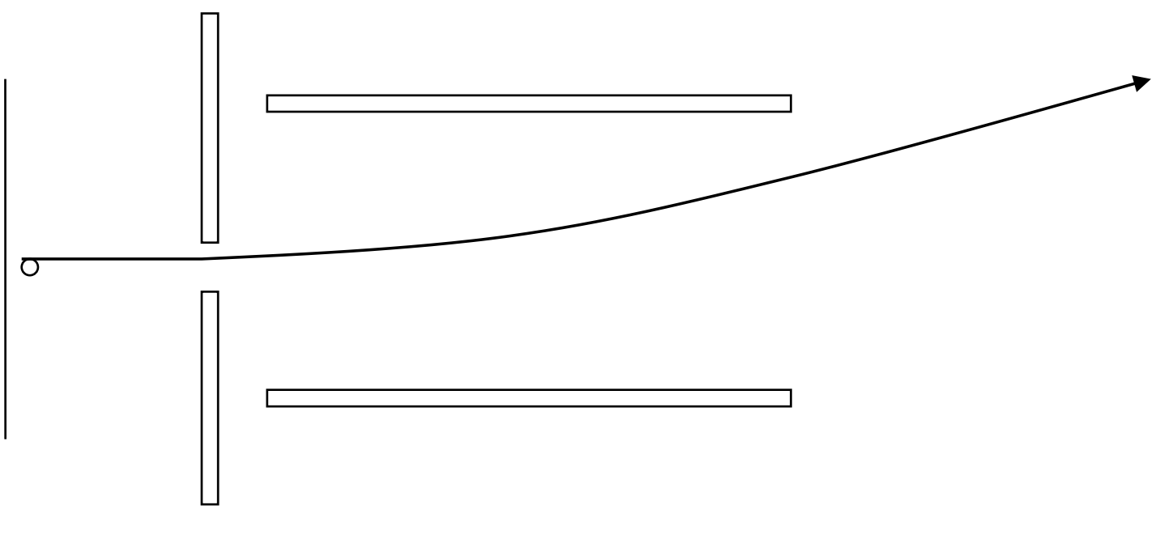

**Q: A lane heated filament emits electrons having negligible kinetic energy. There’s a plate parallel to the filament, situated 5cm away in vacuum that’s maintained at 2000V with respect to the filament.**

**[a] Explain why this would be done in a vacuum.**

If this were not done in a vacuum the accelerating electron would collide with the air gas molecules in the air and the electrons would be deflected or would be lost via ionisation with the molecules.

**[b] If there’s a small hole in the plate and there’s no electric field in the region of space on the side of the plate away from the filament, sketch suitably labelled graphs to indicate how the following quantities vary as a function of distance from the filament to a point 2cm beyond the plate, and sketch the way that the same 3 quantities would vary with distance if the hot filament is replaced by a source that emits heavy. singly-charged negative ions:**

**[i] Acceleration of emitted electrons.**

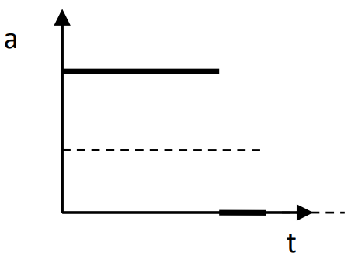

**[ii] Velocity of emitted electrons.**

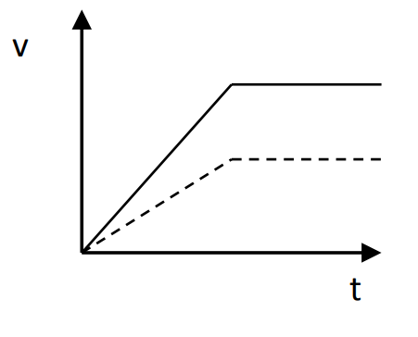

**[iii] Kinetic energy of emitted electrons.**

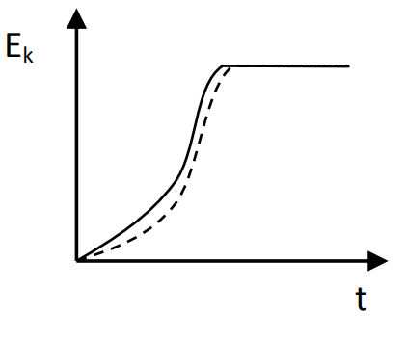

Electron: Solid line.

Ion: Dotted line.

**Charged Particles in Magnetic Fields**

* A small, charged particle (e.g., an electron or proton) isn’t affected by a magnetic field unless the particle is moving across the field lines.
* A moving charged particle creates around itself a small magnetic field.
* The particle’s field interacts with the magnetic field through which the particle is moving as long as the particle’s path crosses field lines.
* The result is that a force acts on the particle perpendicular to its velocity.
* As long as the force is perpendicular to the velocity, the particle moves in a curved path.
* If the particle travels parallel to the field lines, there’s no interaction with the field and hence no magnetic force. Such a particle travels through the magnetic field undeflected.

A charged particle creates a magnetic field around itself. If the charge passes through an area which already has a magnetic field, there will be an interaction – a force will be exerted on the particle.

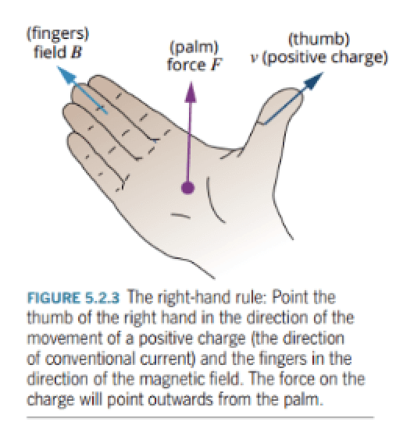

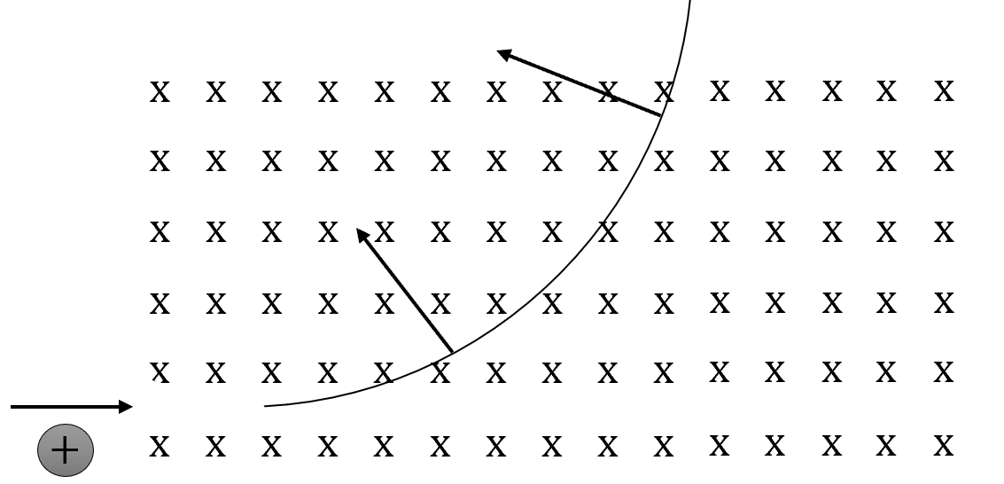

Force

Force

v

F = qvB

Where:

* q is particle charge (C).
* v is particle velocity (ms-1).
* B is magnetic field strength (T).

For a charged particle moving in a circular path:

qvB = $\frac{{mv}^{2}}{r}$ → qB = $\frac{mv}{r}$ → r = $\frac{mv}{qB}$

Magnetic field: The space or region around a magnet or moving electric charge within which the magnetic force operates.

Properties of magnets:

* Magnets all attract objects made of iron.
* All magnets have 2 ends (poles) regardless of shape where the magnetic effect is strongest.
* Magnets which are suspended so that they’re free to rotate align themselves with the Earth’s magnetic field.
* Magnets interact with each other – “like poles repel and unlike poles attract”.

Magnetic materials are made up of areas/domains of tiny particles which themselves act as tiny magnets. When these domains are aligned, it’s then said that the material is magnetised.

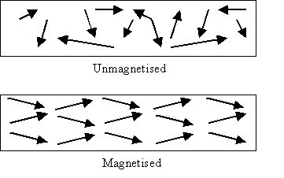

* The direction of the flux lines at any point is the direction that the north of a compass would point.
* The density of the field lines indicates the magnitude of the magnetic field.
* Flux lines never cross each other.

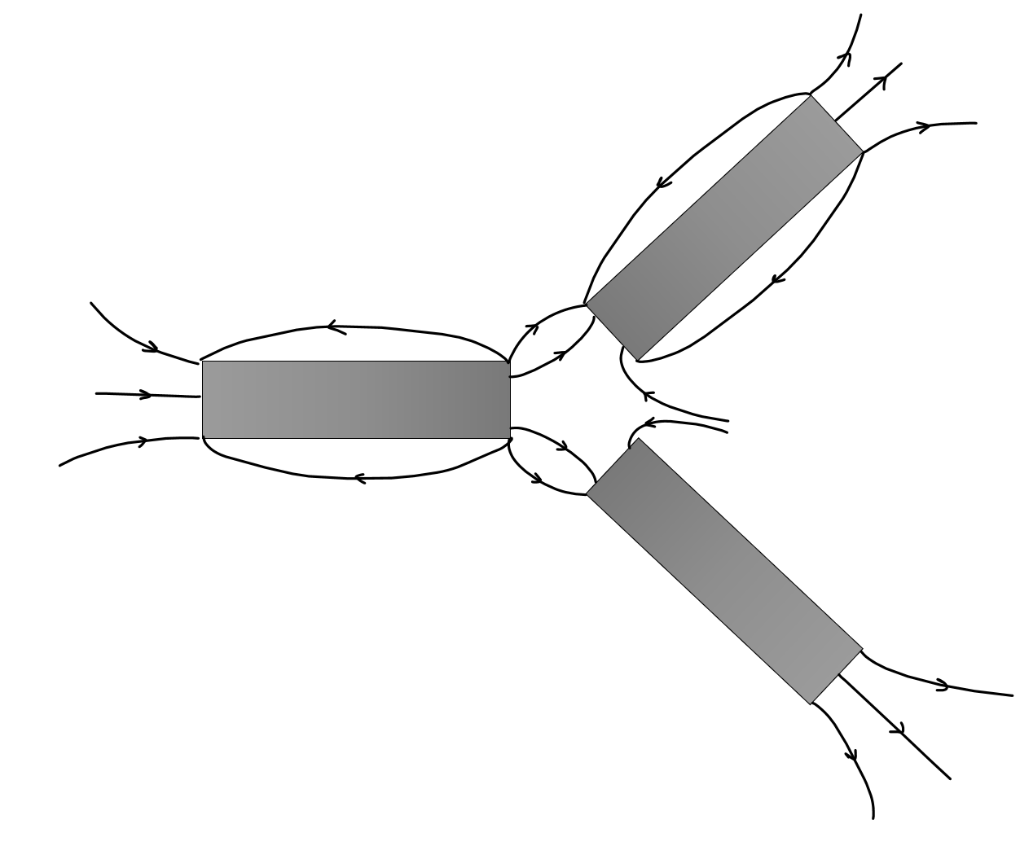

S

S

S

N

N

N

Earth’s magnetic field:

* The magnetic north and south poles are situated near but not at the same point as the geographic poles. The angle of declination is that between the axis of the magnetic poles and geographic poles.
* The Earth’s field is as if the North of a magnet existed at the South magnetic pole.
* At most points of the Earth’s surface, its magnetic field isn’t parallel to the ground. The angle between the Earth’s field and the Earth’s surface is called the angle of dip.

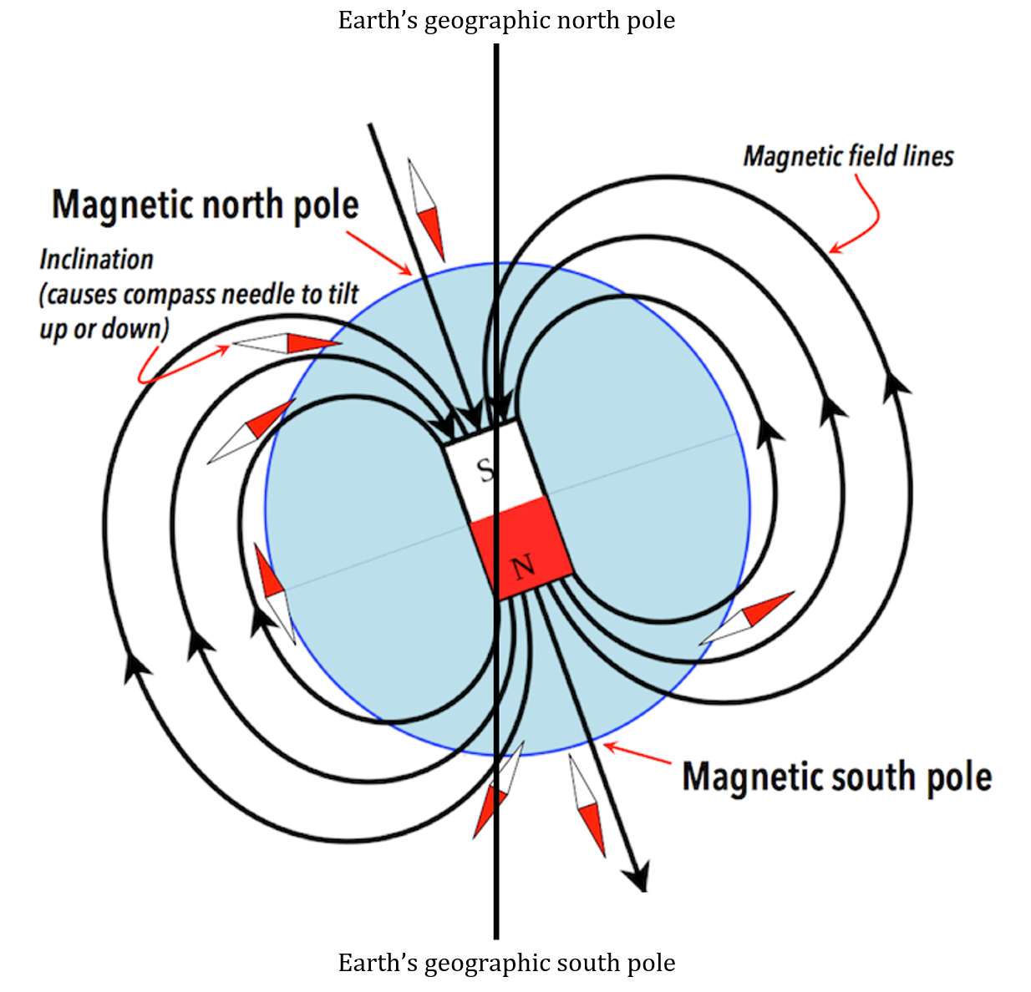

Current in wire loops:

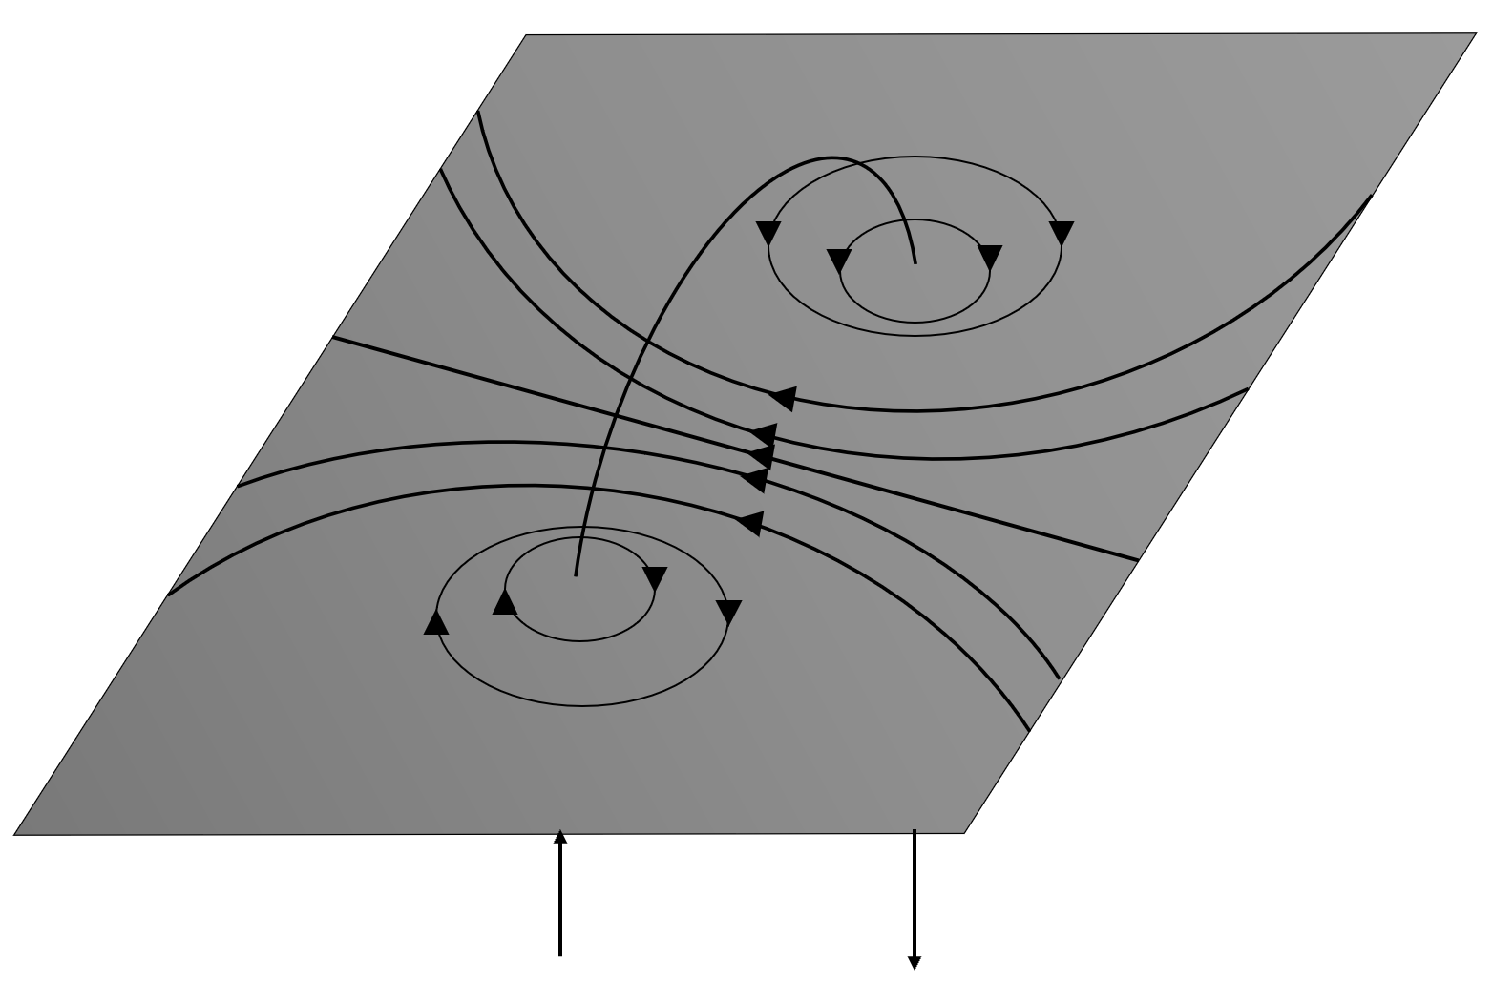

I

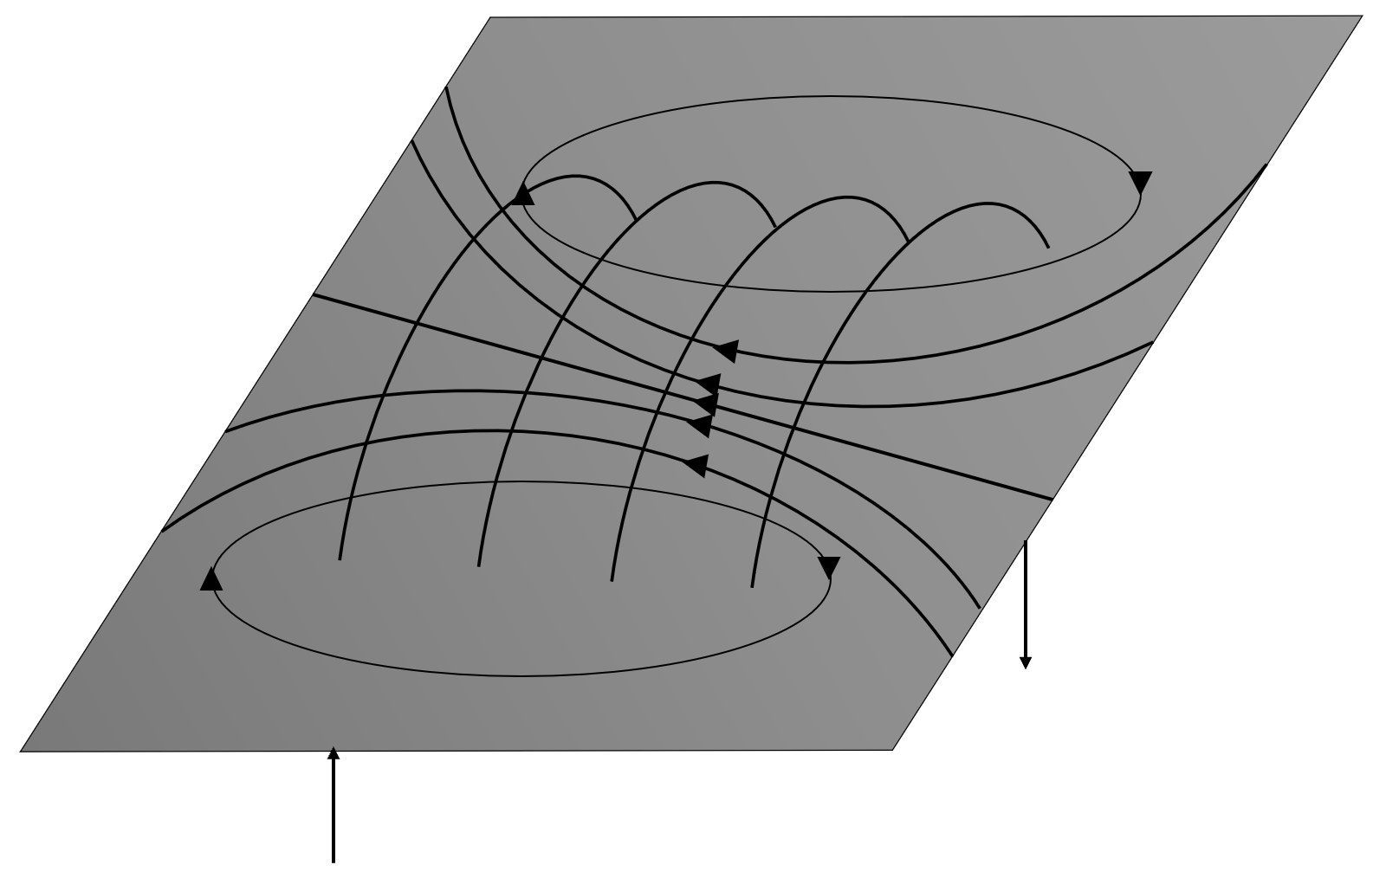

I

B = $\frac{µ_{0}}{2π}\frac{I}{r}$

Where:

* B is magnetic field strength or flux density (Wb m-1 or T).
* I is current (A).
* r is distance from conductor wire (m).
* µ0 is magnetic constant (permeability of free space (4π x 10-7 = 1.26 x 10-2NA-2).

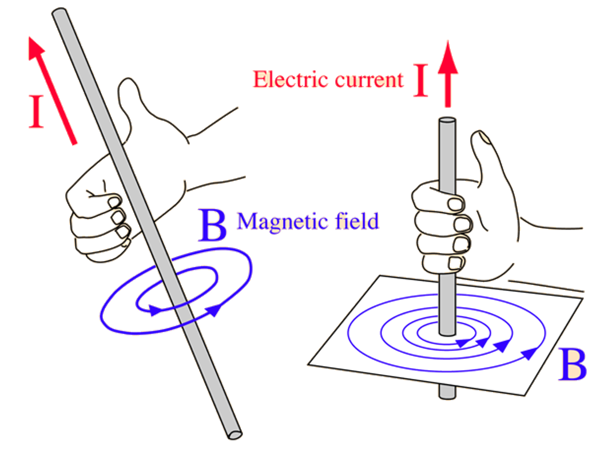

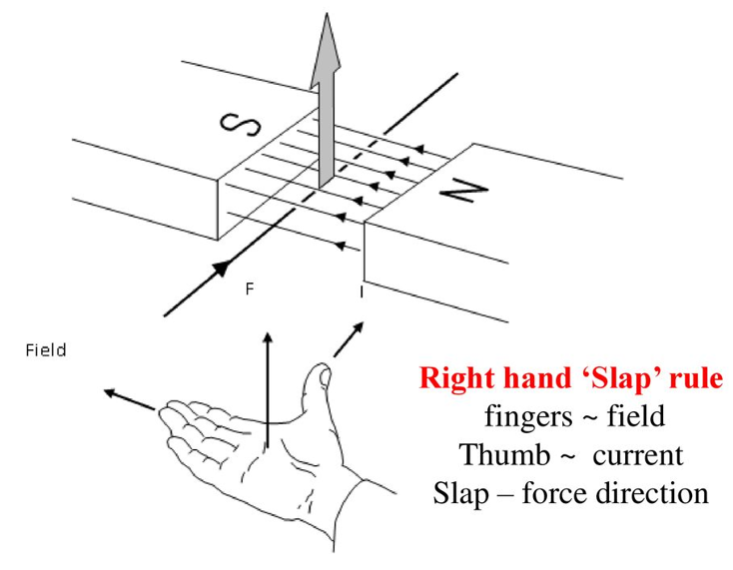

**Set 10**

Shape of the magnetic field surrounding the Earth:

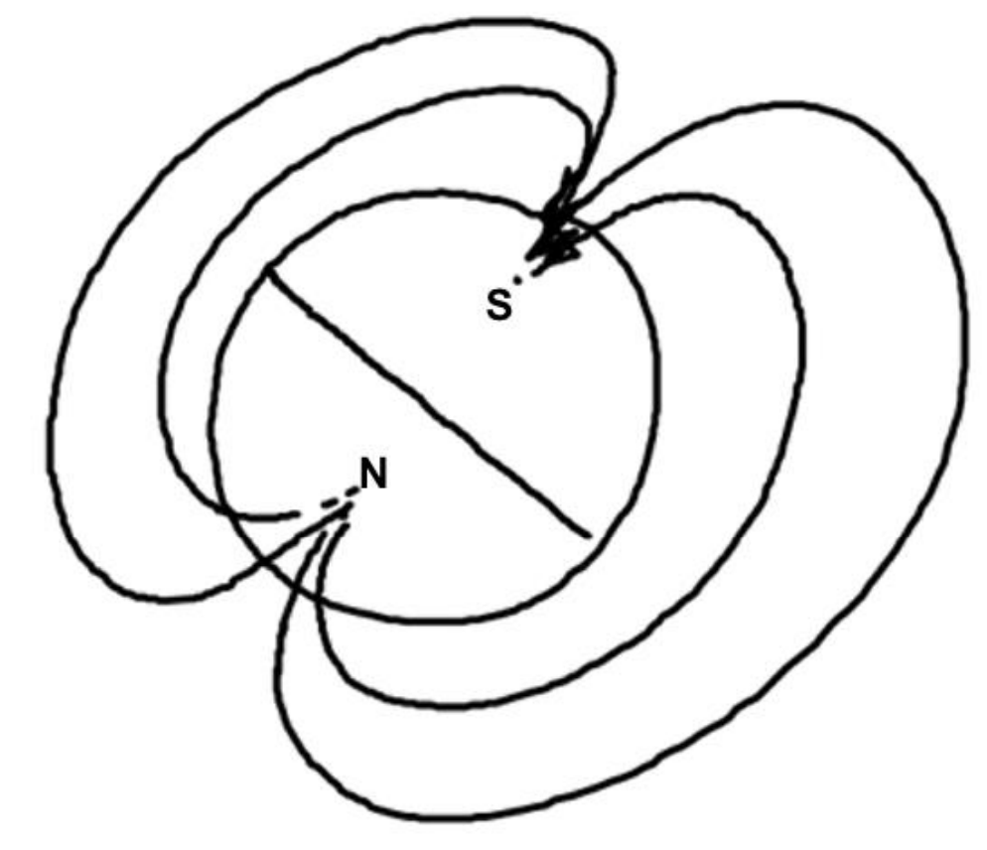

Q: A short straight length of steel wire that has been stroked from end to end with a magnet and a short straight length of copper wire carrying a current each produce a magnetic field.

[a] Describe how these fields differ.

Magnetised wire (left) vs current-carrying wire (right):

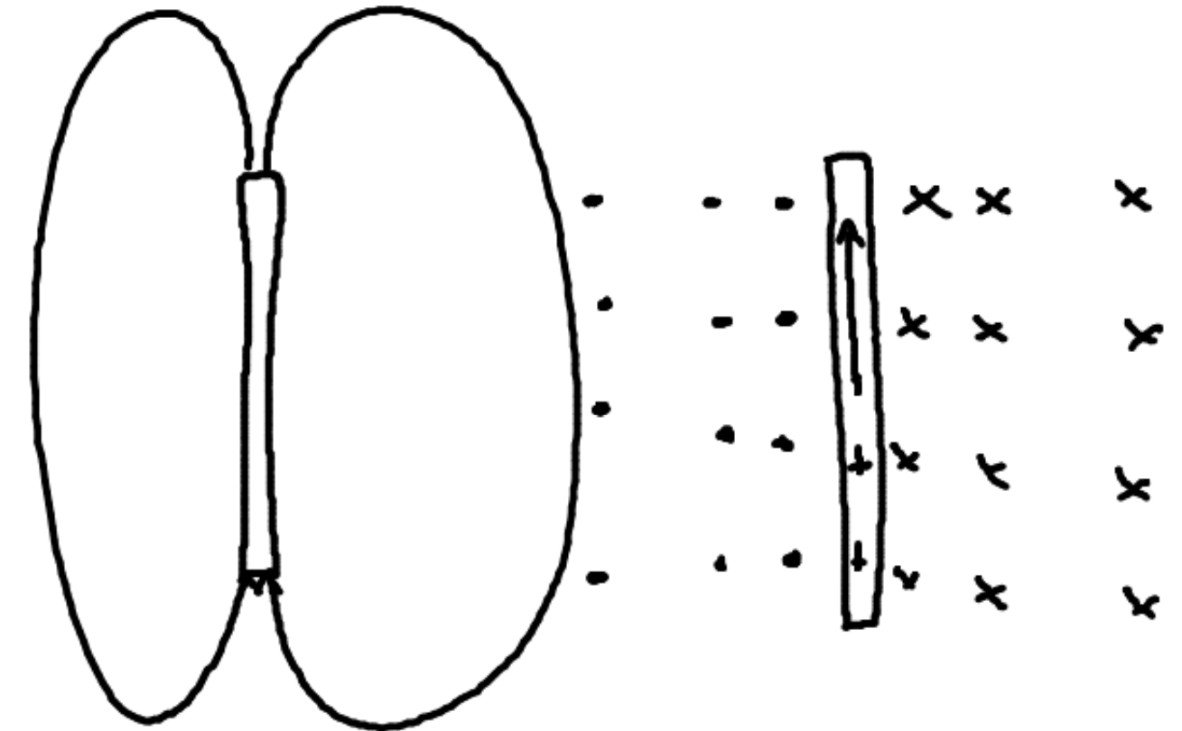

**[b] How could the copper wire be made to produce a field more like the field produced by the steel wire?**

Coil the wire into a solenoid.

**Magnetic field distribution for**:

**[a] A bar magnet.**

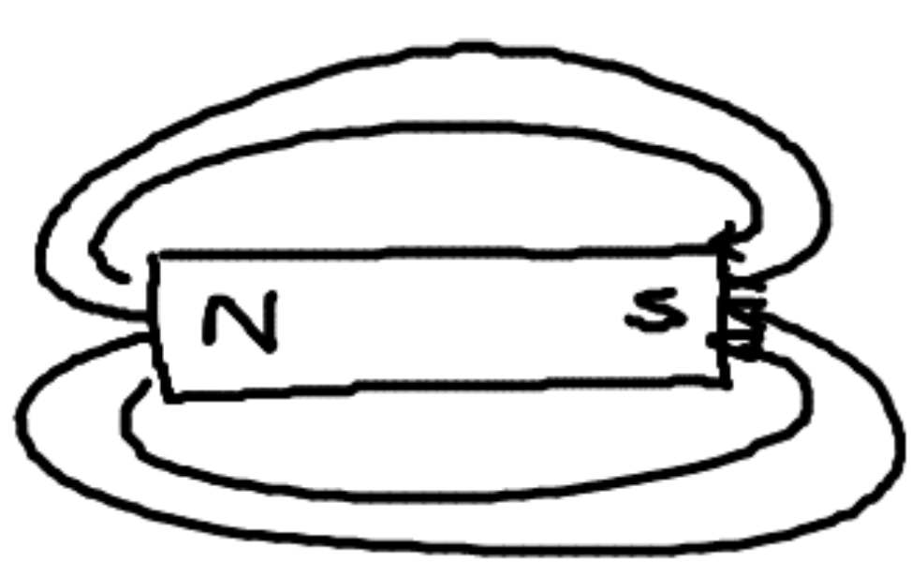

**[b] 2 bar magnets in line with opposite poles facing each other and separated by 50mm.**

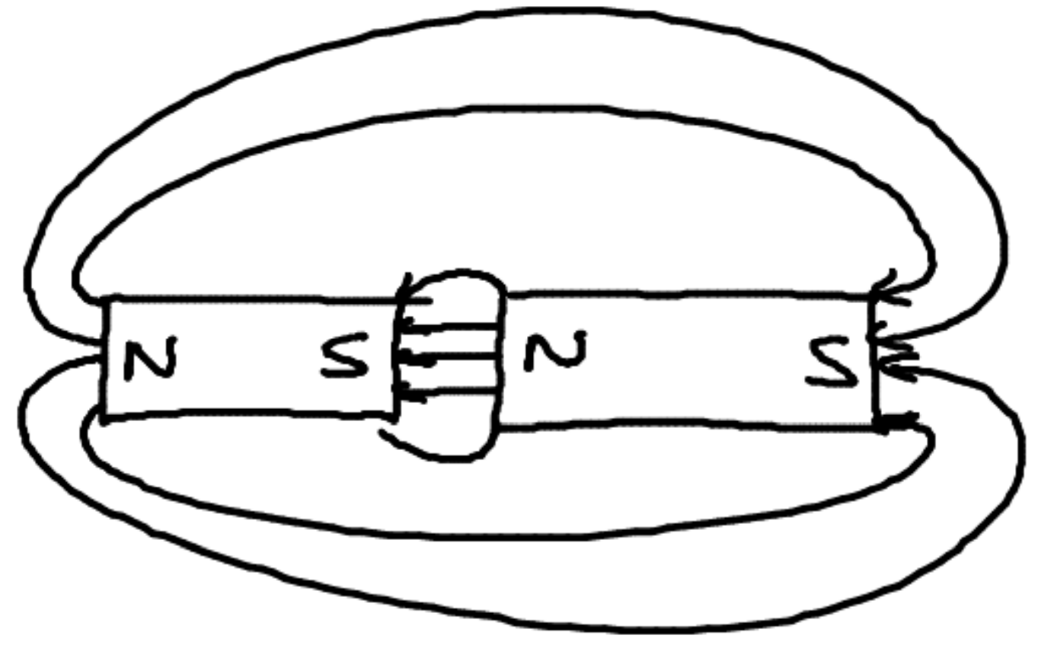

**[c] 2 bar magnets in line with similar poles facing each other and separated by 50mm.**

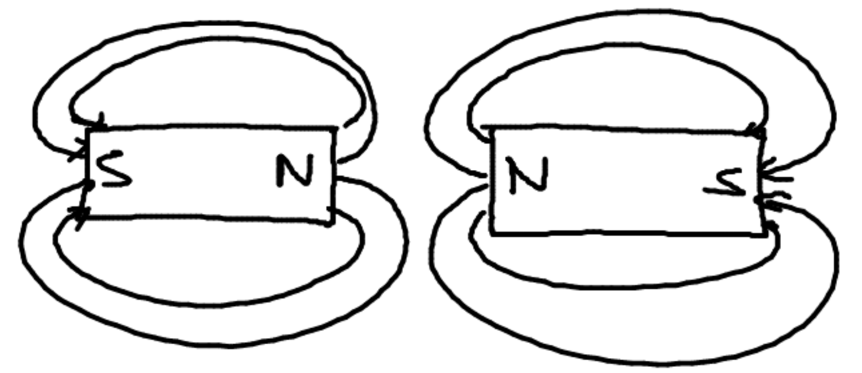

**[d] 2 bar magnets placed parallel to each other about 50mm apart and with opposite poles adjacent.**

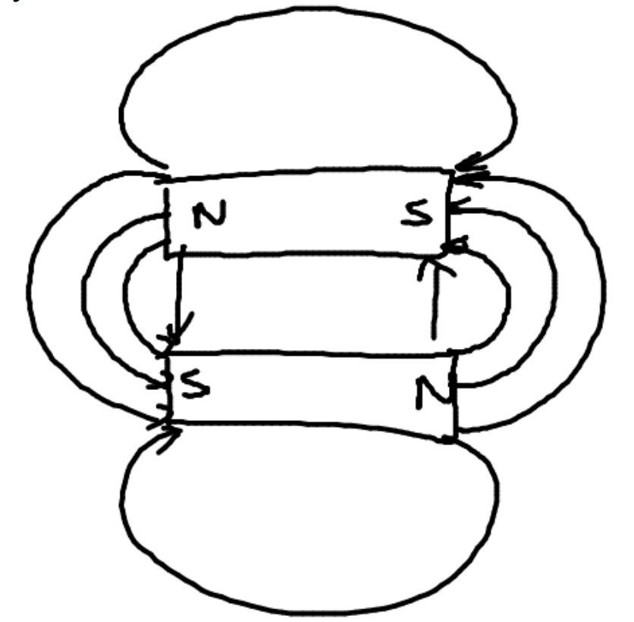

**[e] 2 bar magnets in line separated by 80mm with opposite poles facing and with a small iron washer placed midway between them:**

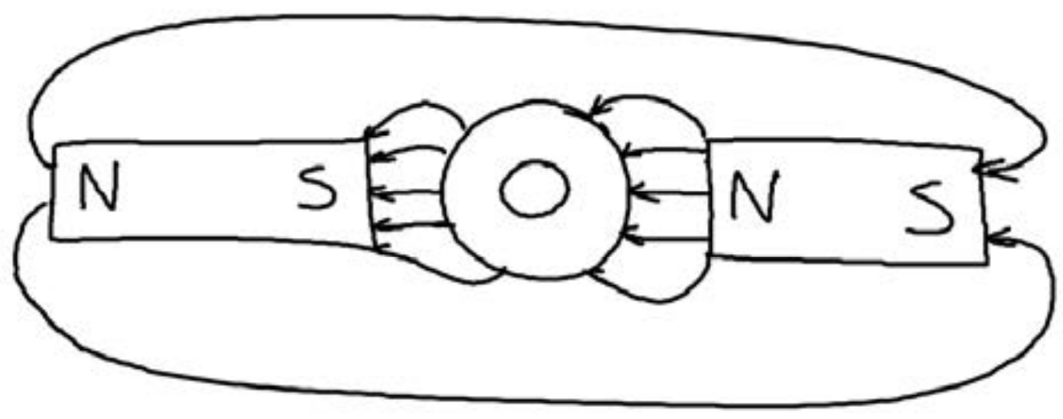

**Magnetic field pattern for**:

**[a] A single straight current-carrying copper wire.**

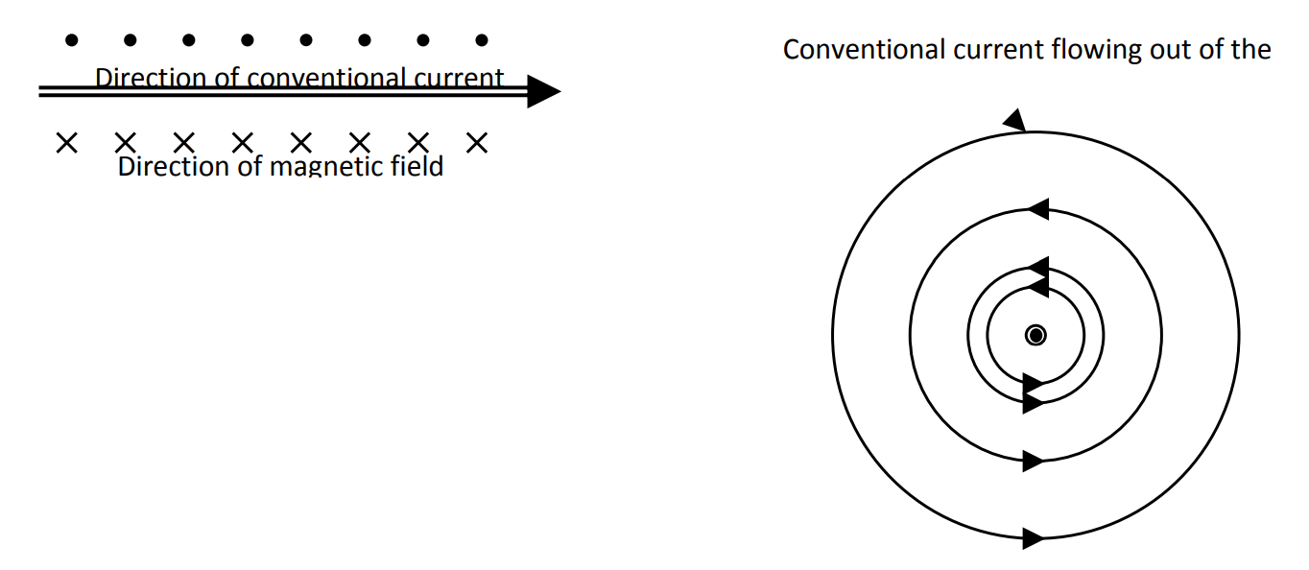

**[b] A current-carrying circular coil of wire.**

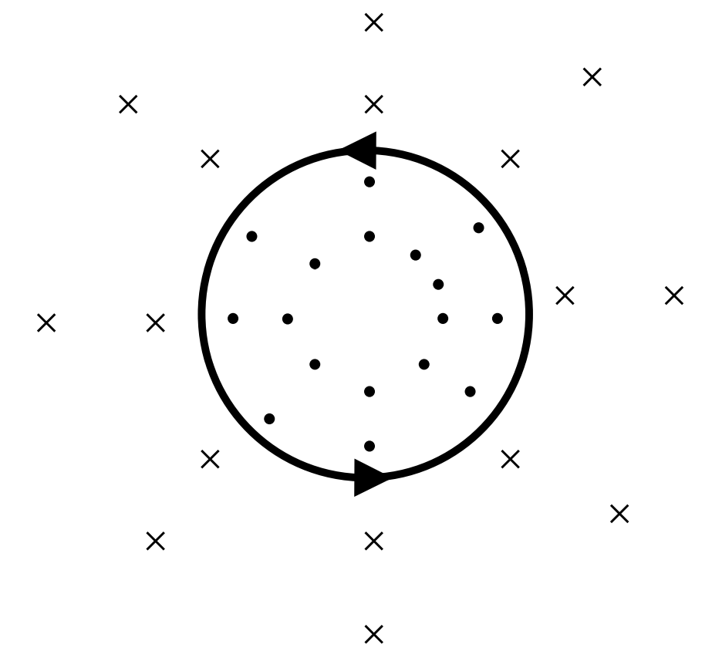

**Q: An electron, travelling at a constant speed, enters a region of uniform magnetic field. Describe the subsequent motion of the electron if the field direction is:**

**[a] Parallel to the electron’s direction of motion.**

No change in direction. Velocity is parallel with field.

**[b] Perpendicular to the electron’s direction of motion.**

Electron will change direction because of a force according to the right hand rule.

**Q: Particles C, D and E follow the paths shown in the following diagram as they pass through a magnetic field. What conclusions can you draw about the charged on particles C, D and E?**

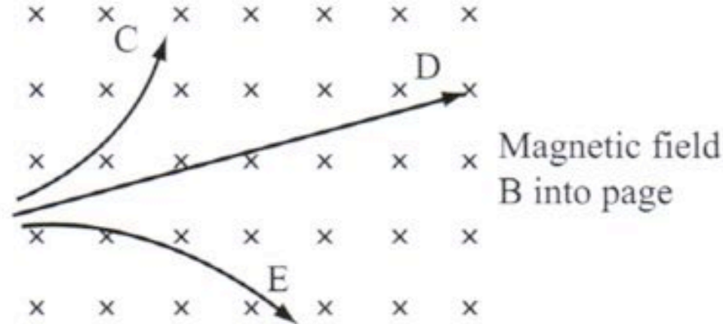

A is positive B is uncharged and C is negative.

**Q: A proton moving in a uniform magnetic field travels perpendicular to the field and remains in the field. Explain how the time for one revolution might change if the proton’s initial velocity is greater.**

As the v increases the radius of the circle increases according to r = $\frac{mv}{qB}$ If the radius of the circle increase the circumference increases by the formula 2π($\frac{mv}{qB}$) Hence the time taken is constant by the formula v = $\frac{2π(\frac{mv}{qB})}{T}$.

**Q: An electron microscope uses a “magnetic lens” to focus a wide beam of electrons to a point, as shown in Diagram A. In tis case, all the electrons have the same speed.**

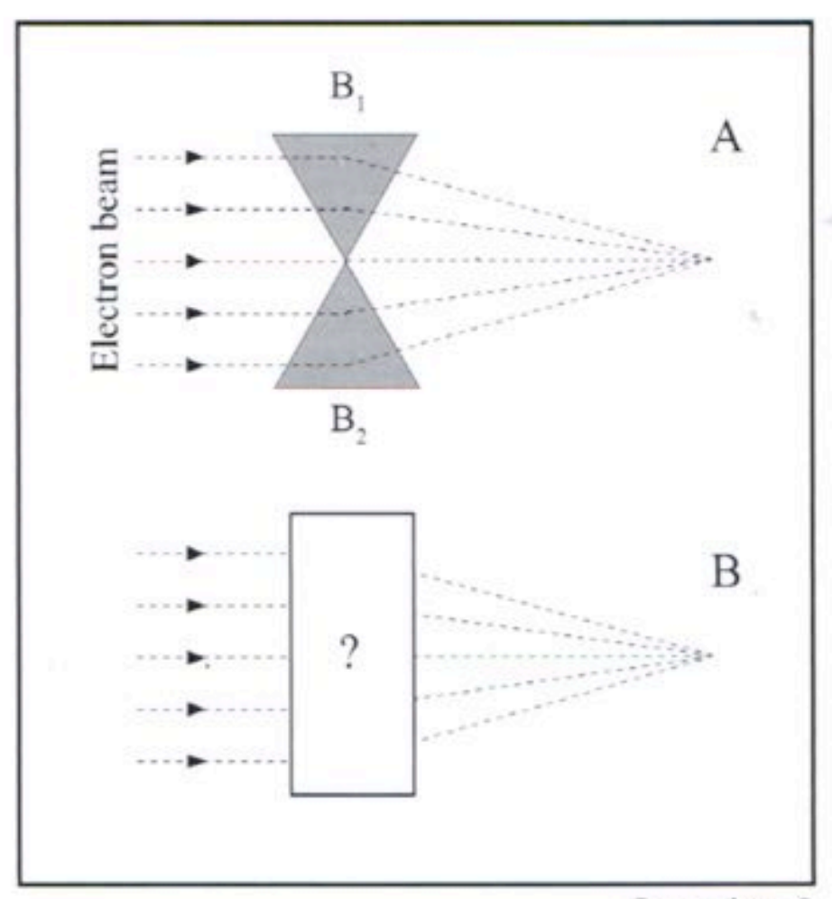

**[a] The triangular shape of the magnetic field deviates the outer electrons more than the inner electrons. Explain.**

The electrons are in the field for longer. The causes them to experience a force for longer and increases the amount of deflection they experience.

**[b] If the magnetic field wasn’t triangular but had the shape shown in Diagram B, how could you achieve different amounts of deviation?**

Make the field non uniform so that the field is stronger at the top and bottom edges of the rectangle. The direction of the field will reverse halfway down the triangle

**[c] What would be the directions of magnetic fields B1 and B2?**

B1 is into the page and B2 is out of the page.

**Charged Particles in Combined Electric and Magnetic Fields**

A charged particle experiences a force when it’s affected by:

* An electric field – The field acts on the particle’s charge whether the particle is moving through the field or is stationary. F = Eq.
* A magnetic field that’s at an angle to the direction in which the particle is moving – When the field is perpendicular to the direction of the particle’s velocity. F = vqB.
* A gravitational field affecting its mass – This happens whether the particle is moving through the field or is stationary. F = mg.

An electric and a magnetic field can exist in the same space. Each can deflect a particle passing through. If the electric and magnetic fields are correctly oriented, a charged particle may pass through them undeflected. This only occurs at a particular velocity, and an arrangement of “crossed fields” is sometimes called a velocity filter.

|  |  |  |
| --- | --- | --- |
| **Field**: | **Similarities**: | **Differences**: |
| Electric field F = Eq | Force depends on:   * Magnitude of the field * Magnitude of charge | Force is:   * Parallel to the field * Independent of velocity |
| Magnetic field  F = qvB | Force depends on:   * Magnitude of the field * Magnitude of charge | Force is:   * Perpendicular to field * Dependent of velocity |

**Set 11**

**Subsequent motion of a proton that enters**:

**[a] A uniform electric field parallel to the field lines.**

Proton accelerates parallel with field. Proton may accelerate positively or negatively depending on the direction of the field and sign convention.

**[b] A uniform magnetic field parallel to the field lines.**

No force on charged particle moving parallel with field lines.

**[c] A uniform magnetic field perpendicular to the field lines.**

Proton accelerates parallel with field. Proton may accelerate positively or negatively depending on the direction of the field and sign convention. proton is deflected sideways relative to original line of motion.

**[d] A uniform magnetic field perpendicular to the field lines.**

Proton begins to move in a circle because it is experiencing a force as it cuts across magnetic field lines.

**Q: An electron is fired vertically downwards between 2 vertical, parallel, charged metal plates. The west plate has a positive potential with respect to the east plate. To exactly balance the effect of the electric field, what must be the direction of a magnetic field in this region?**

As seen from a top view looking down, electric field is west to east. The magnetic field will need to be North to South.

**Q: A narrow electron beam enters a region at a speed of 6.00 x 106ms-1 and is suddenly influenced by a magnetic field.**

**[a] Describe and explain the effect of the electrons in the beam if the field is perpendicular to the beam.**

The field has a turning effect on the electron.

**[b] Describe and explain the effect on the electrons in the beam if the field is parallel to the beam.**

The electron passes straight through undeviated. There is no force on the electrons when travelling parallel to the magnetic field.

**[c] The electron beam leaves the magnetic field and enters a region in which there exists an electric field. Describe the path of the electrons in the beam if the field is in the same direction as the beam.**

Electron decelerates linearly and bounces back in the same direction for which it came.

|  |  |  |
| --- | --- | --- |
|  | Electric field: | Magnetic field: |
| Deflection direction (positive charge) | Deflected with field. | If perpendicular to the field, deflected perpendicular to velocity and field according to the right hand rule. |
| Effect of velocity | Doesn’t affect the magnitude (force) of deflection (F = qE (no v term)). | Does affect the force of deflection (F = qvB (contains v term)). |

**Q: Show in a diagram how an electric field and a magnetic field can be arranged so that together they produce no resultant force on an electron passing through them.**

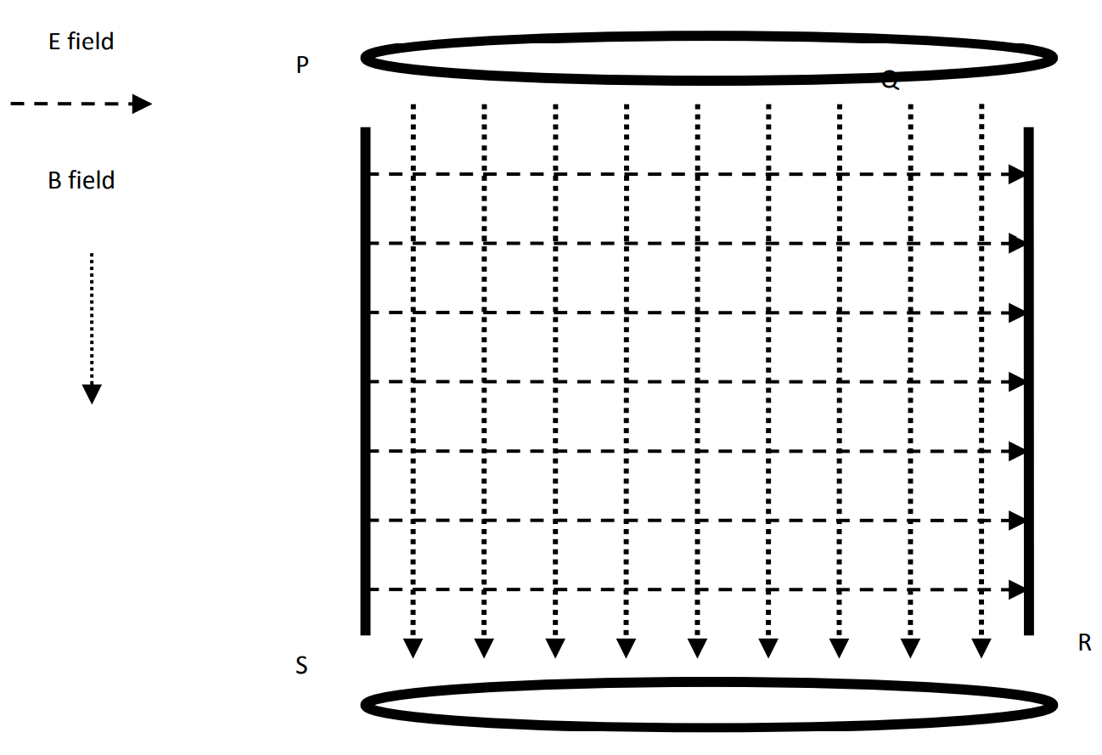

**Q: An electron travelling at 1.60 x 104ms-1 enters a region where there exists a uniform magnetic field of 3.00 x 10-2T perpendicular to the electron’s path.**

**[a] Show in a labelled diagram the vectors representing the motion of the electron, the magnetic field and the electric field.**

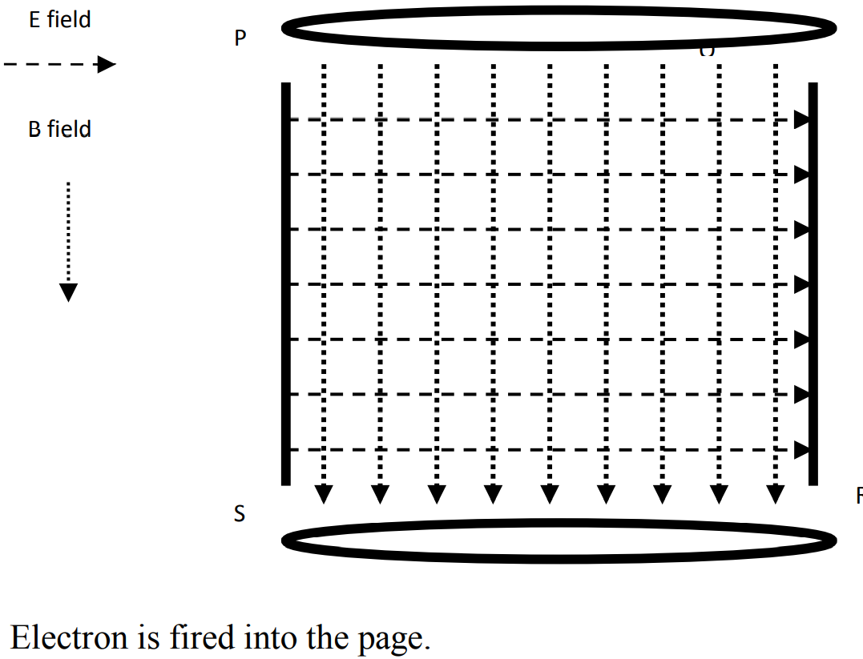

**[b] A second electron travelling a velocity greater than 1.60 x 104ms-1 enters the same region. Describe the paths of both electrons through the region, indicating the direction of both the magnetic and electric fields.**

Original electron travelling at 1.6 x 104 ms-1 passes through un-deviated; faster electron is bent more by the magnetic field and so in the above diagram, bents to the right.

**Q: A cyclotron accelerates small, charged particles in a circular path to very high speeds, then releases the particles to strike a target and make radioisotopes. The cyclotron shown accelerates protons that start at its centre. These travel in circles because of 2 magnetic fields called dees. An alternating electric field in the gap between the dees accelerates the protons to higher velocities.**

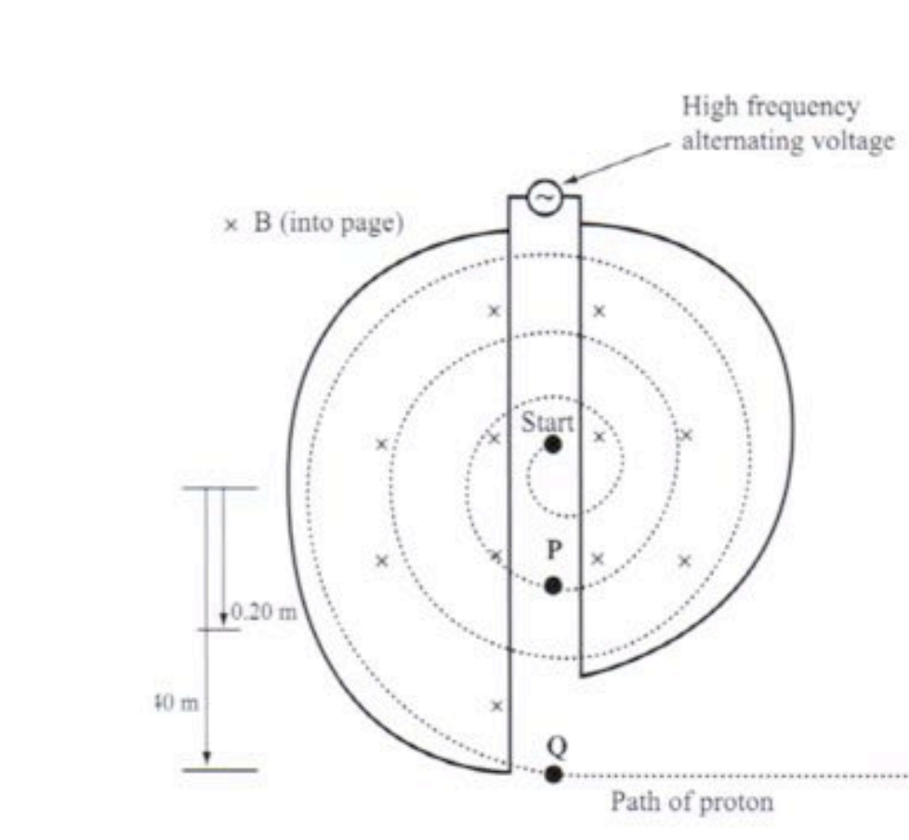

**Why does the proton’s path radius increase?**

The radius increases because the velocity of the charged particle increases as it moves from one D to the next. As v increases r increases.

**Devices**

The cathode ray oscilloscope (CRO) can be described as a simple type of TV set which can measure and display electrical information. It essentially displays voltage in a graphical form. It consists of a large, evacuated tube. Its important parts are:

* A heater and electron gun.
* Focusing and accelerating anodes.
* Deflection plates (horizontal and vertical).
* A fluorescent screen.

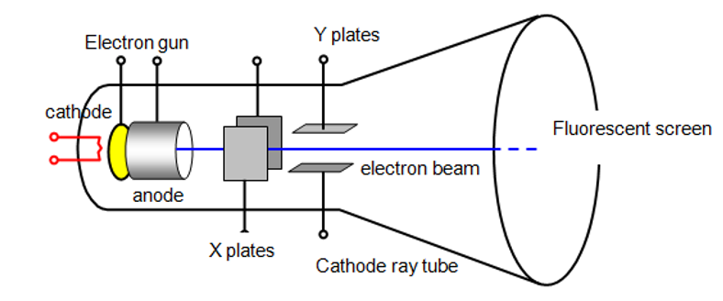

DC electric motor:

* A simple electric motor consists of a coil of wire carrying a current in a magnetic field.
* Current passes through brushes and split rings (commutator) into the coil (armature).
* A turning effect (torque) is created by equal and opposite forces acting on 2 sides of the coil.
* For DC current, a split ring commutator is necessary to reverse the current flow each 180°.

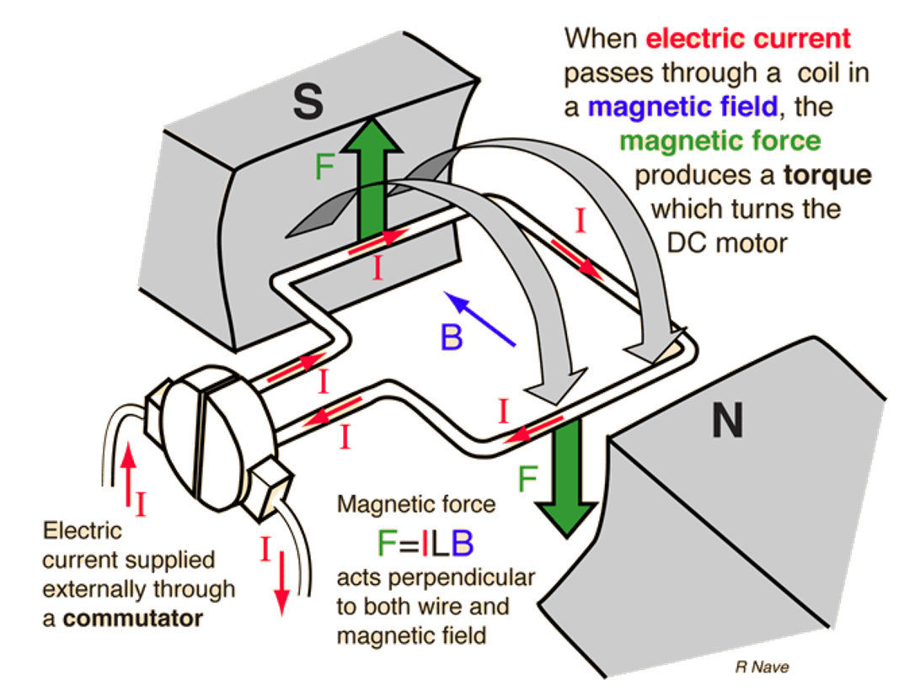

Torque on a DC motor coil:

* The flow of current in a coil creates forces on the parts of the coil which are perpendicular to the magnetic field.
* A downward force acts on one side of the coil and an equal but upward force acts on the other side. These equal and opposite forces create a turning effect.
* No forces act on the sides of the coil where the current is travelling parallel to the magnetic field.
* The torque created by the forces acting on each side of the coil depend on their perpendicular distance from the axis of rotation – this is a maximum when the plane of the coil is parallel to the magnetic field.

$$τ=r_{⊥}F \left(one side\right)$$

$$τ=r_{⊥}Ilb \left(one side\right)$$

$$τ_{total}={2r}_{⊥}Ilb$$

Motor principle: When a current-carrying coil is placed in a magnetic field, a force on the coil results.

It’s also true that when a coil is placed in a changing magnetic field, a current results in the coil – this means if production of an electric current is called electromagnetic induction.

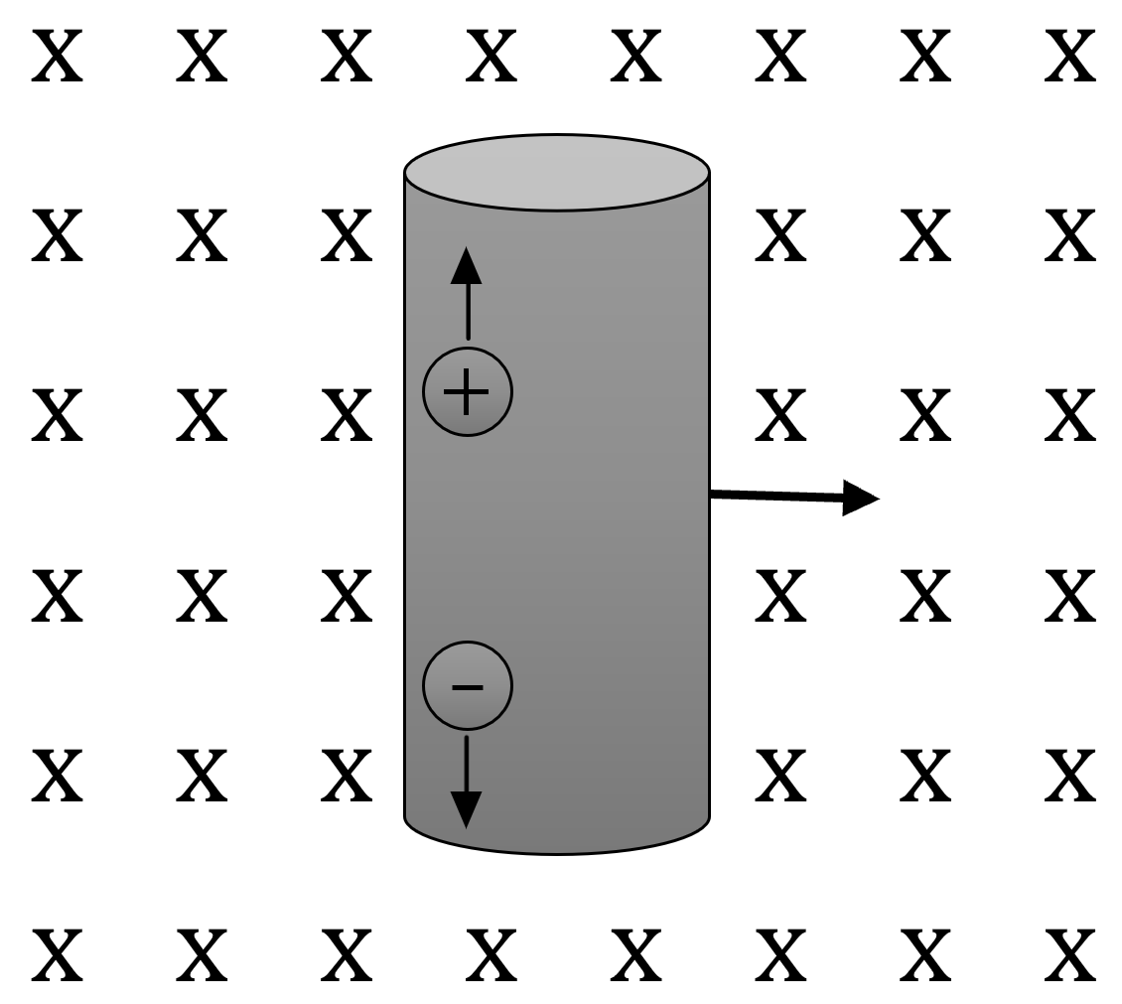

v

F

F

To achieve an emf, we need a coil and a magnetic field with relative movement or change between them. This an be achieved by a:

* Change in magnetic flux passing through a coil e.g.,
* Magnet is brought closer to or taken away from a coil.
* The current in an electromagnet near a coil is increased or decrease.
* Change in the effective area of the coil e.g.,
* Coil rotated so that area facing field changes.
* Coil shape changes and area increases or decreases.

The rate at which any of the above occur determines the magnitude of the emf.

Mass spectrometer:

* Measures the masses and relative concentrations of atoms and molecules.
* Uses include determining isotopic masses, assisting in radioactive dating and identifying small traces of contaminants or toxins.

Step of mass spectrometry:

1. Vaporisation – The sample is vapourised in a vacuum chamber.
2. Ionisation – The gaseous sample is placed in a strong electric field which produces positive ions.
3. Acceleration – The ions are accelerated by another electric field.
4. Deflection – The ions enter the mass spectrometer perpendicular to a very strong magnetic field in a vacuum.
5. Detection – The ions then follow a circular path whose radius is measured by the position of the detectors.
6. Velocity selector – Sometimes used prior to the ionised particles entering the mass spectrometer since the variation in the measured radius of curvature will only depend on the mass of the charged particle. It’s used if just identifying masses.

* Any difference in charge would give distinctly different results compared to small changes in masses and hence is easily accounted for.
* The mass spectrum gives distinctive peaks for each isotope.

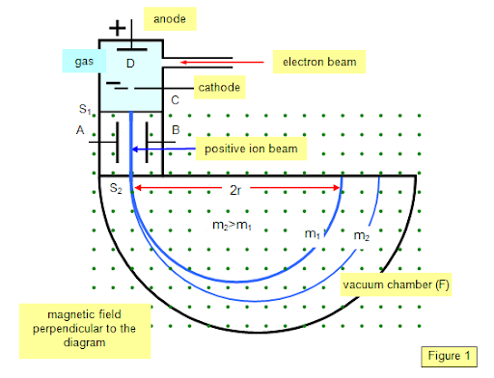

Notes for Analysis Test 5/5/2021

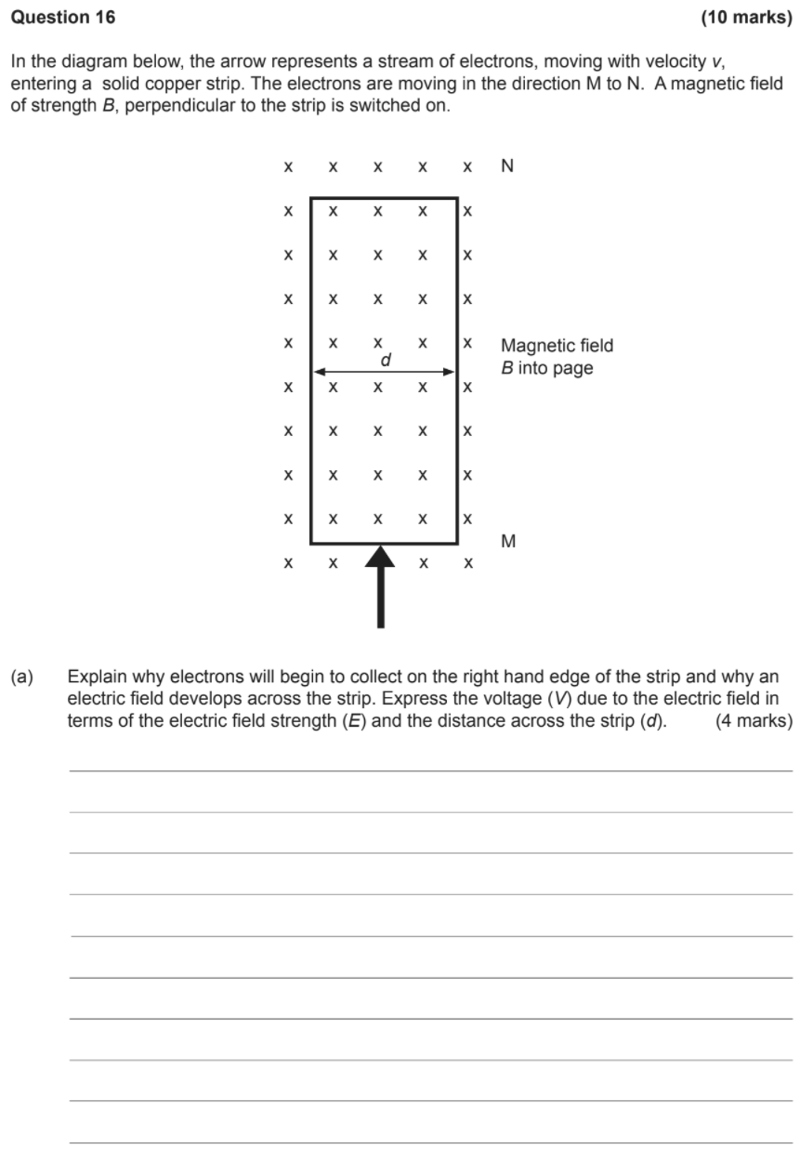

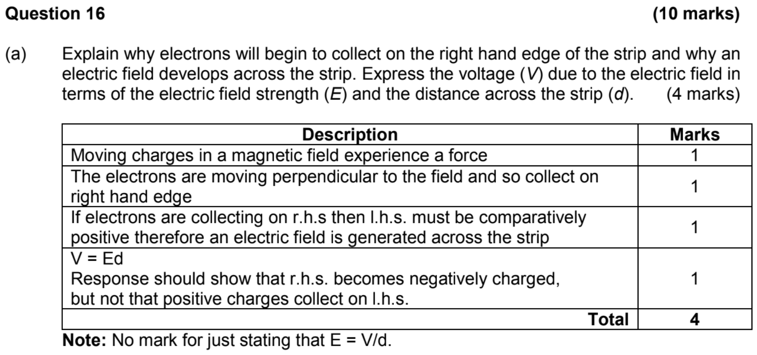



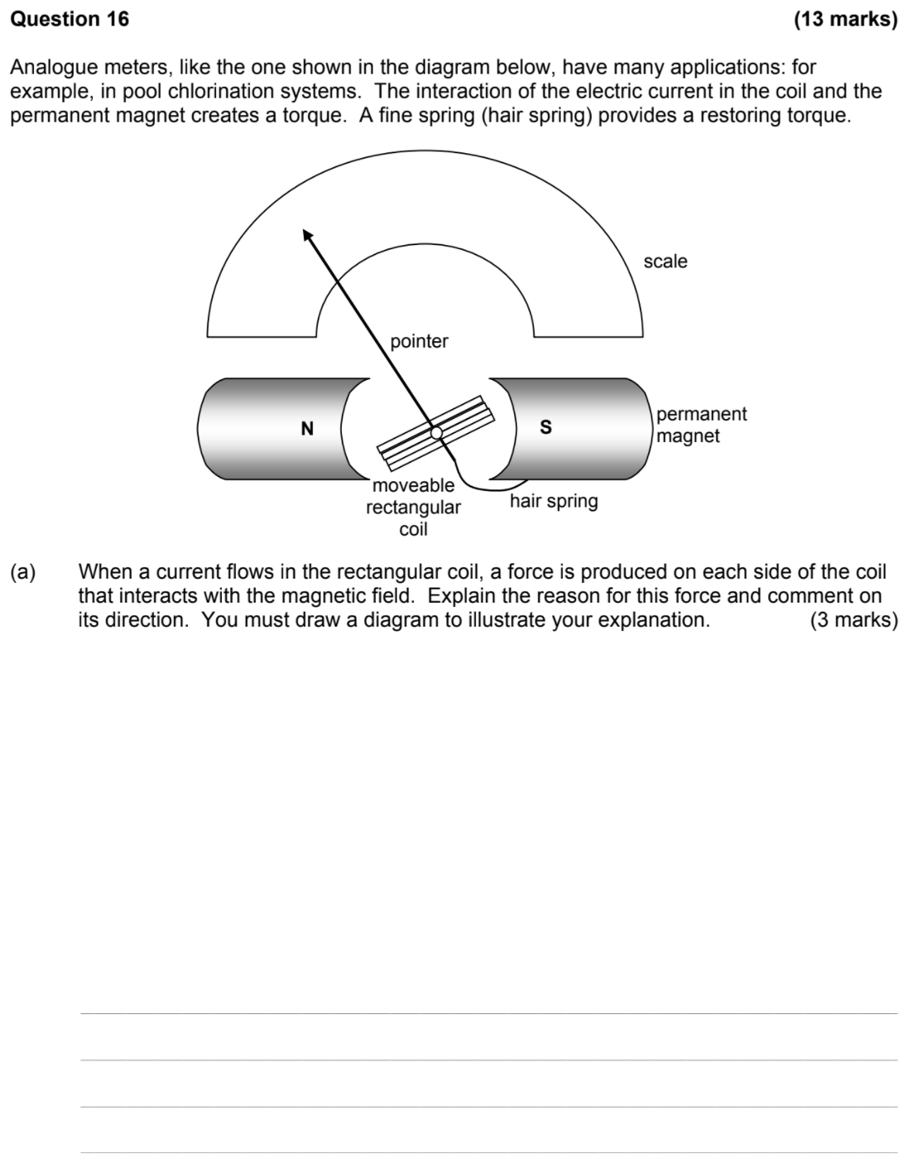

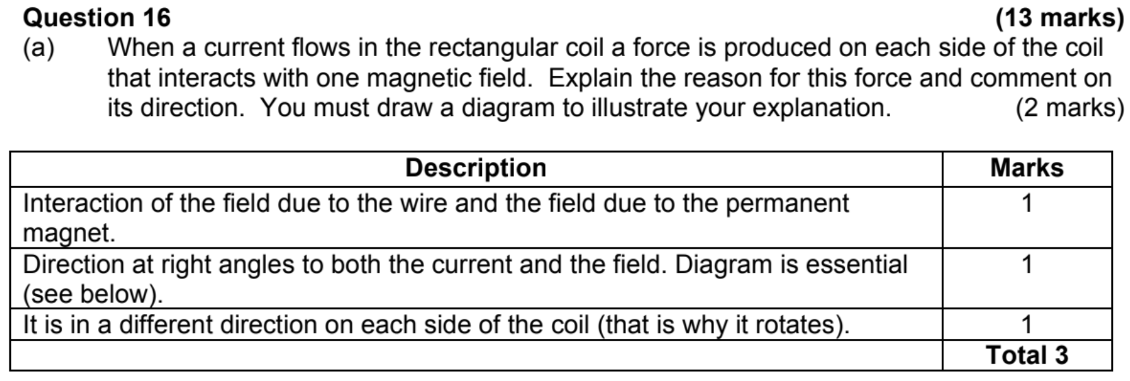



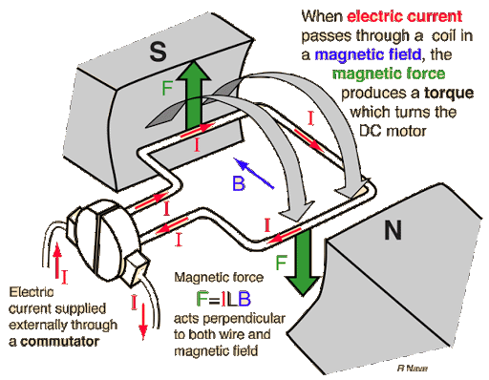



|  |  |
| --- | --- |
| Description | Marks |
| The coil has many turns and can rotate on an axis between the north and south poles of magnets. | 1 |
| The current is led into the coil through a split-ring commutator and carbon brushes. | 1 |
| The permanent magnetic field due to the stator interacts with the current through the armature to produce a force upward on one side of the coil and downwards on the other. | 1 |
| This produces a torque which will rotate on the coil. | 1 |
| As the coil becomes vertical, the current reverses due to the split ring, reversing the direction of the current and hence reversing the direction of the force. | 1 |
| This keeps the coil rotating in the same direction. | 1 |
|  | Total 6 |

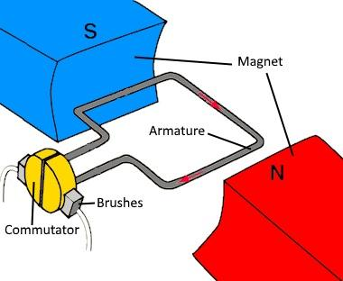

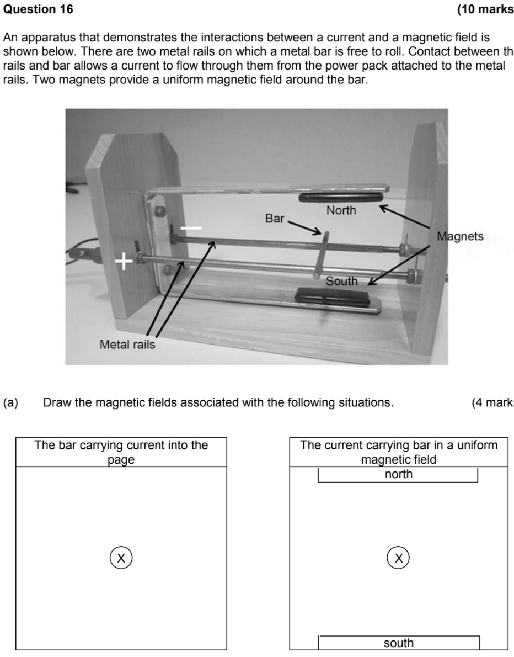

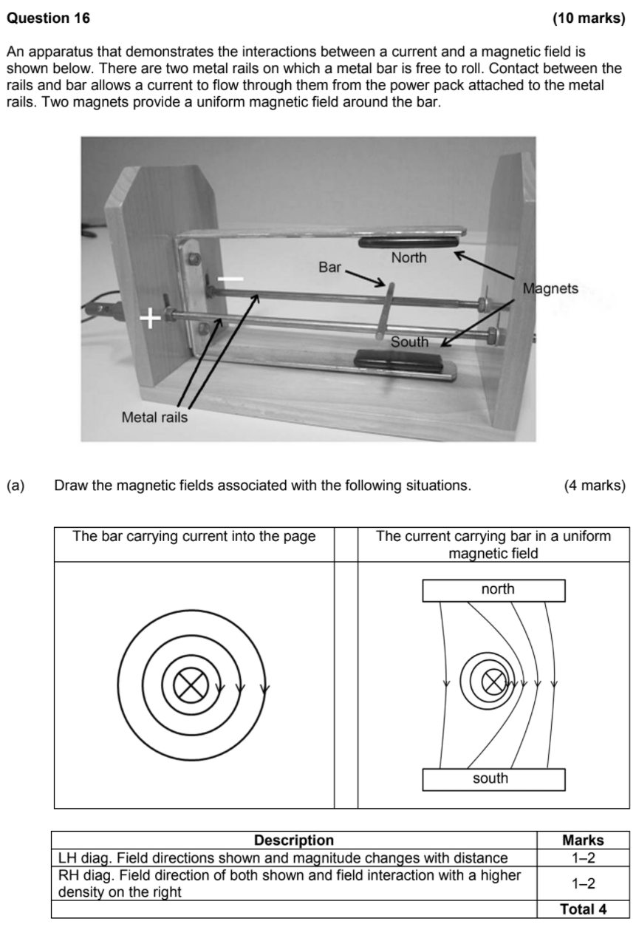

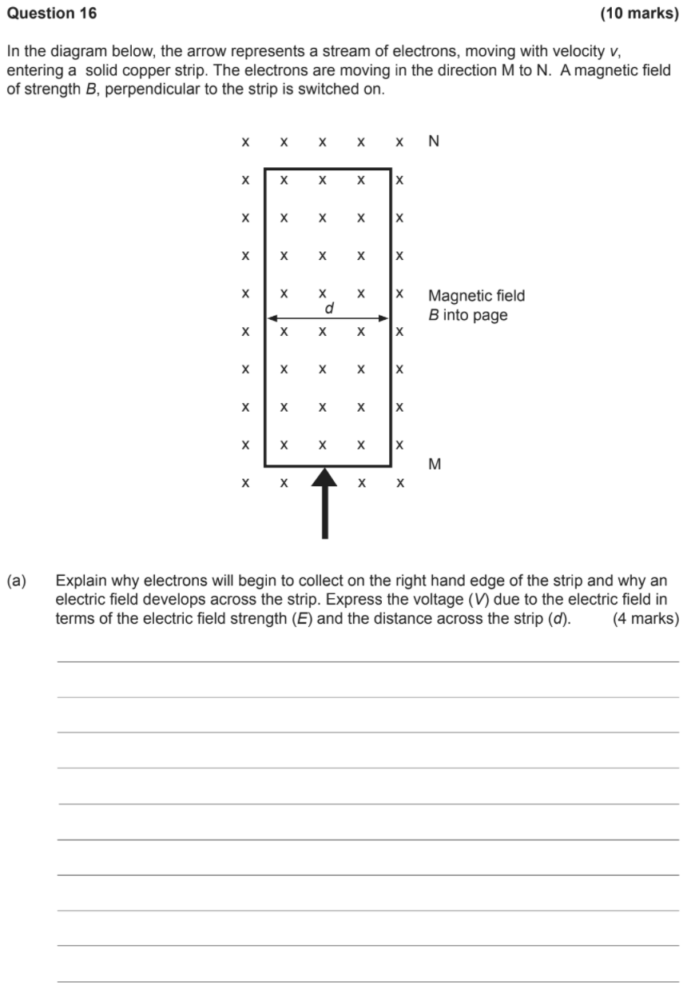

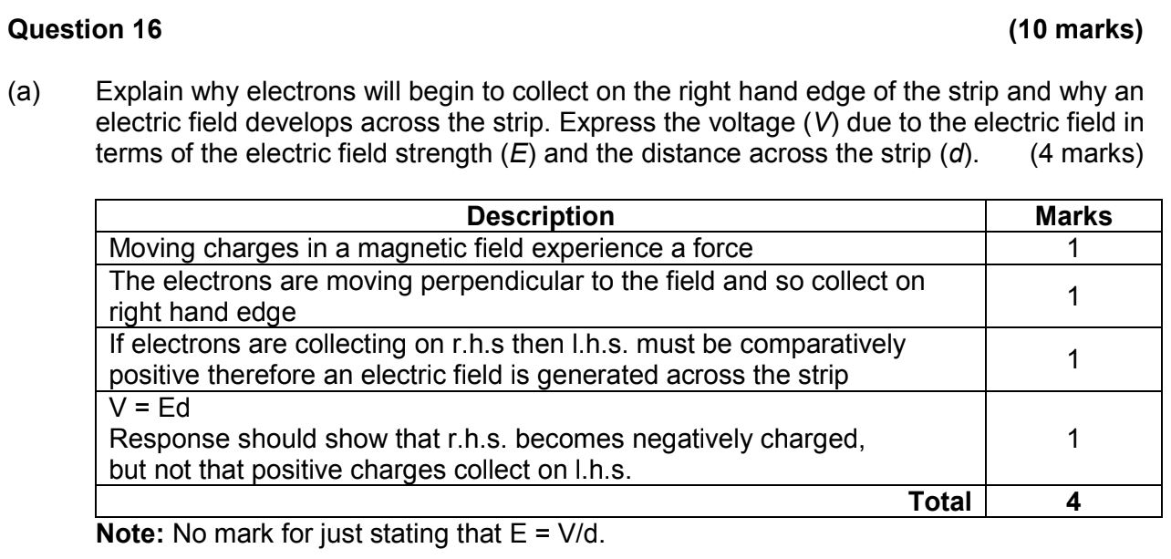

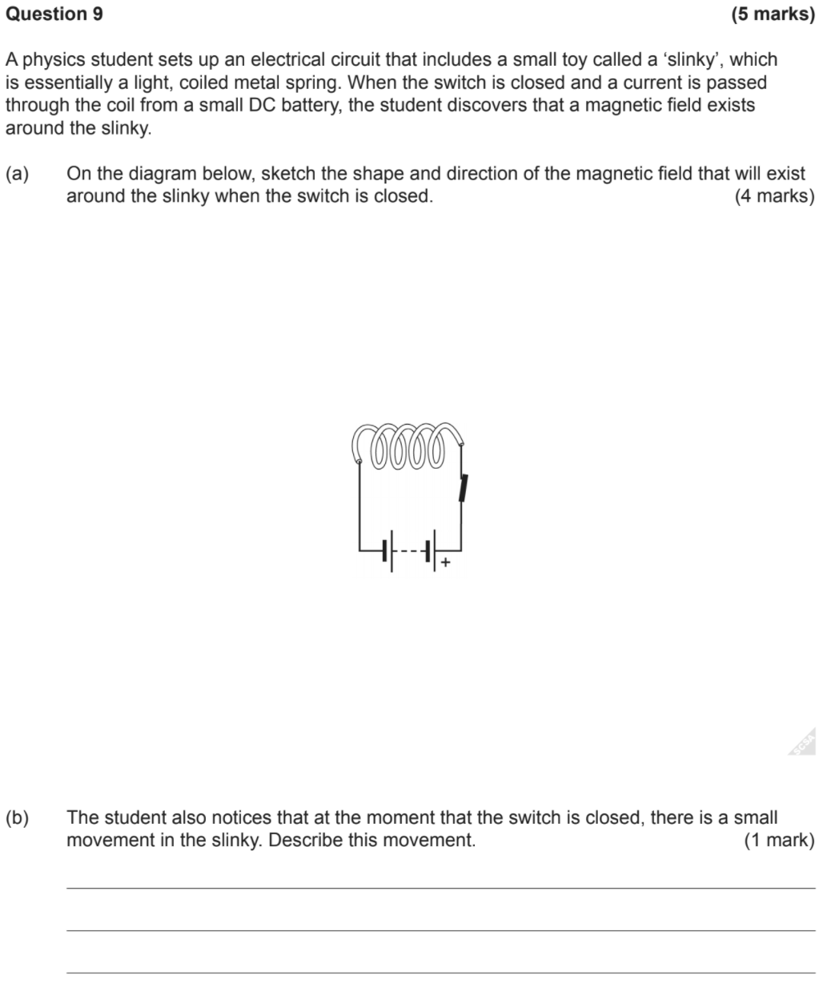

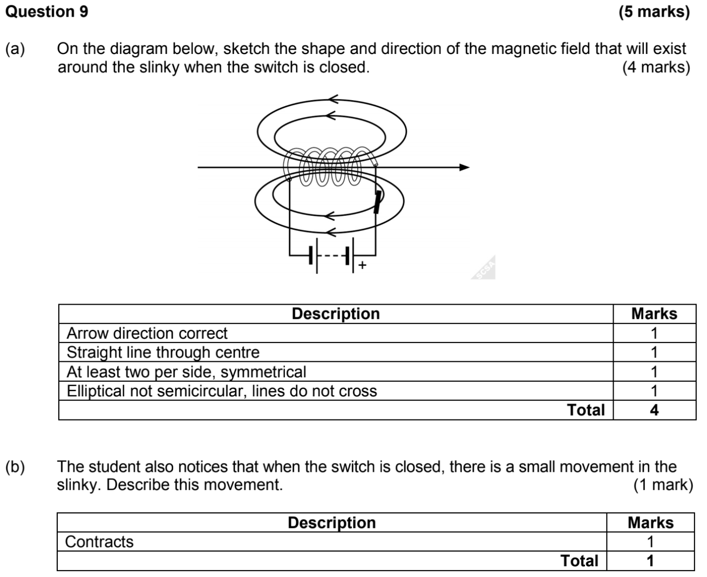

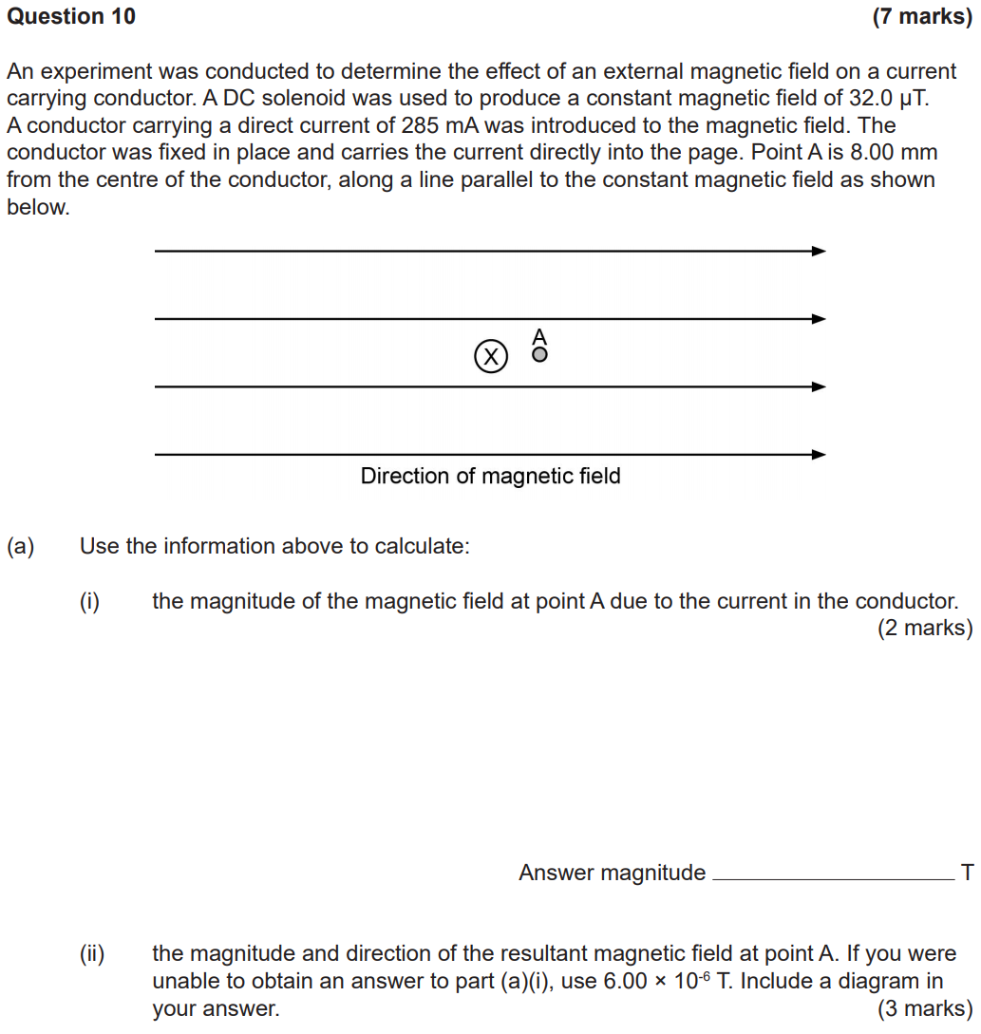



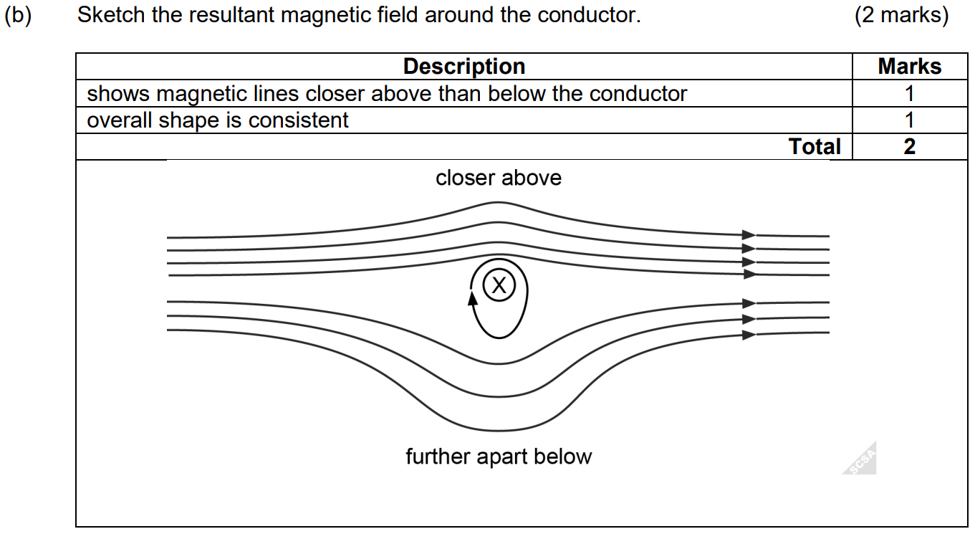

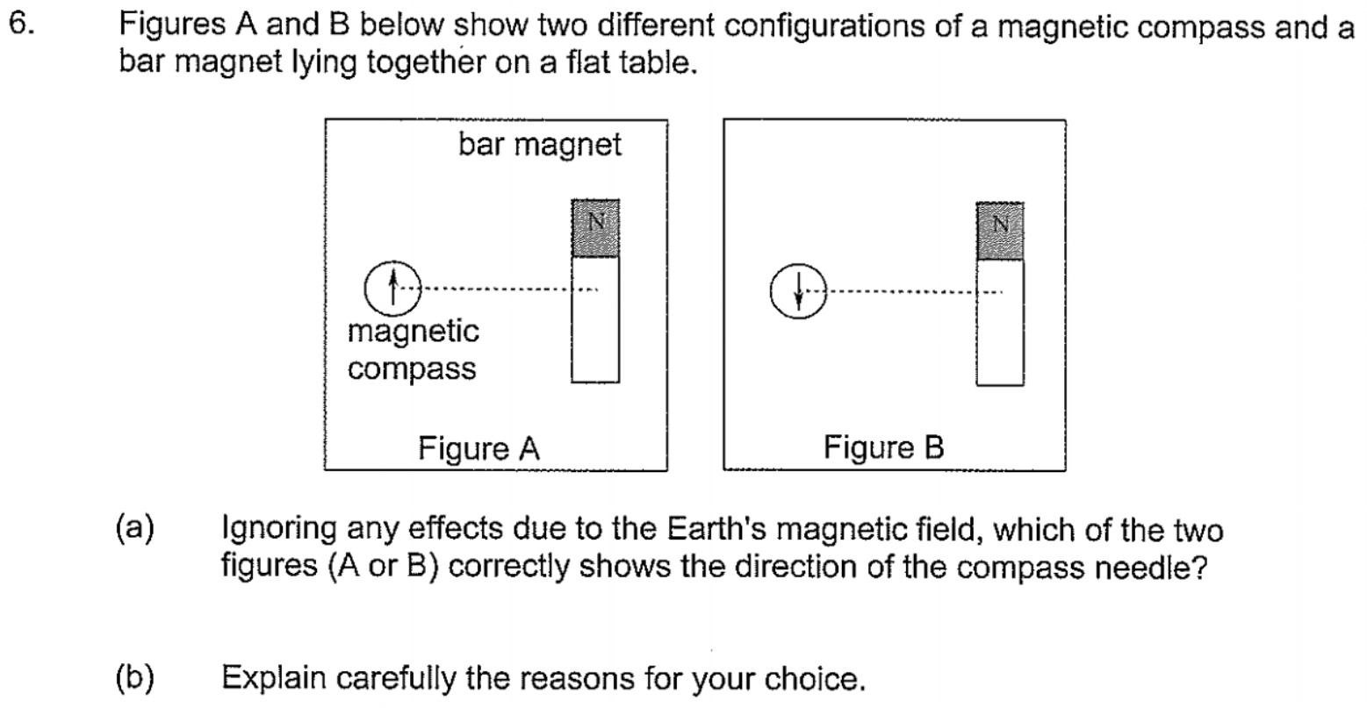

Part [a]: B is correct.

|  |  |
| --- | --- |
| Description | Mark |
| The arrow of the compass needle aligns itself with the field lines of the magnet. | 1 |
| The field is downwards at the compass. | 1 |
| Diagram | 1 |
|  | Total 3 |

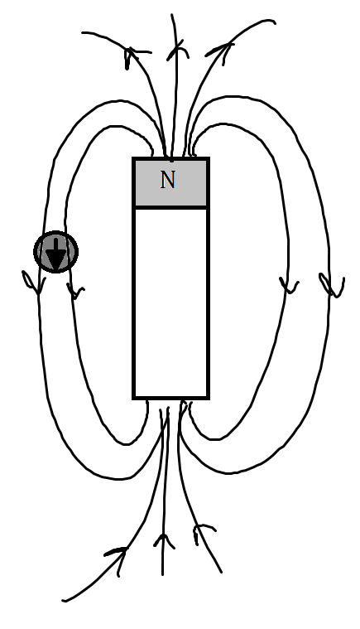

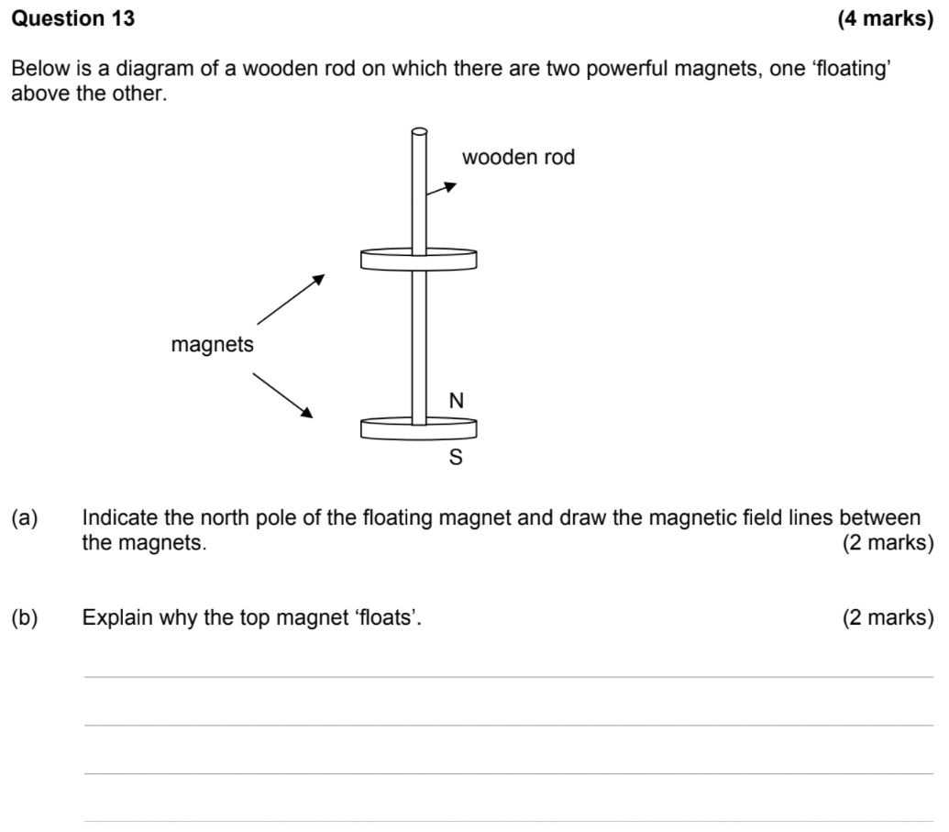

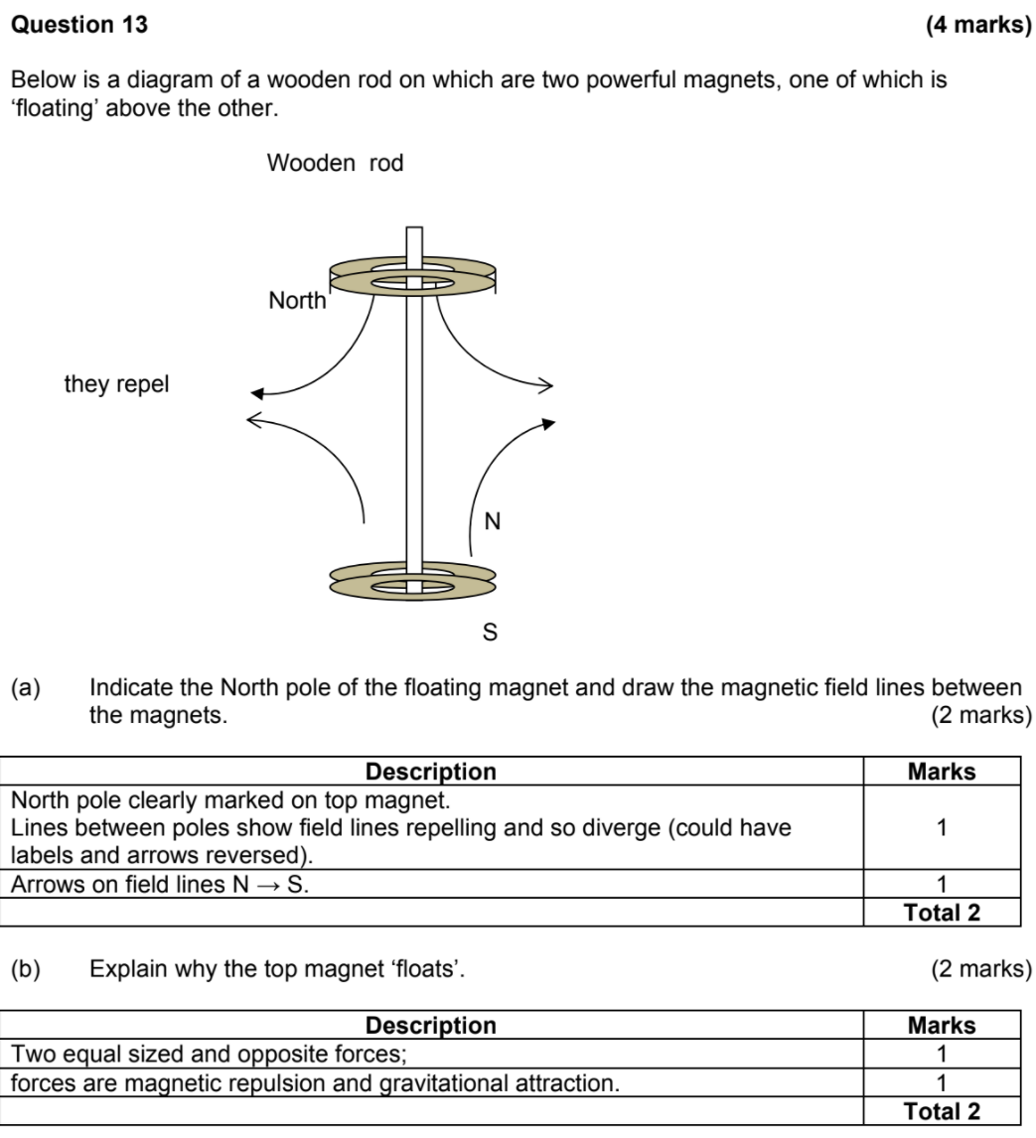

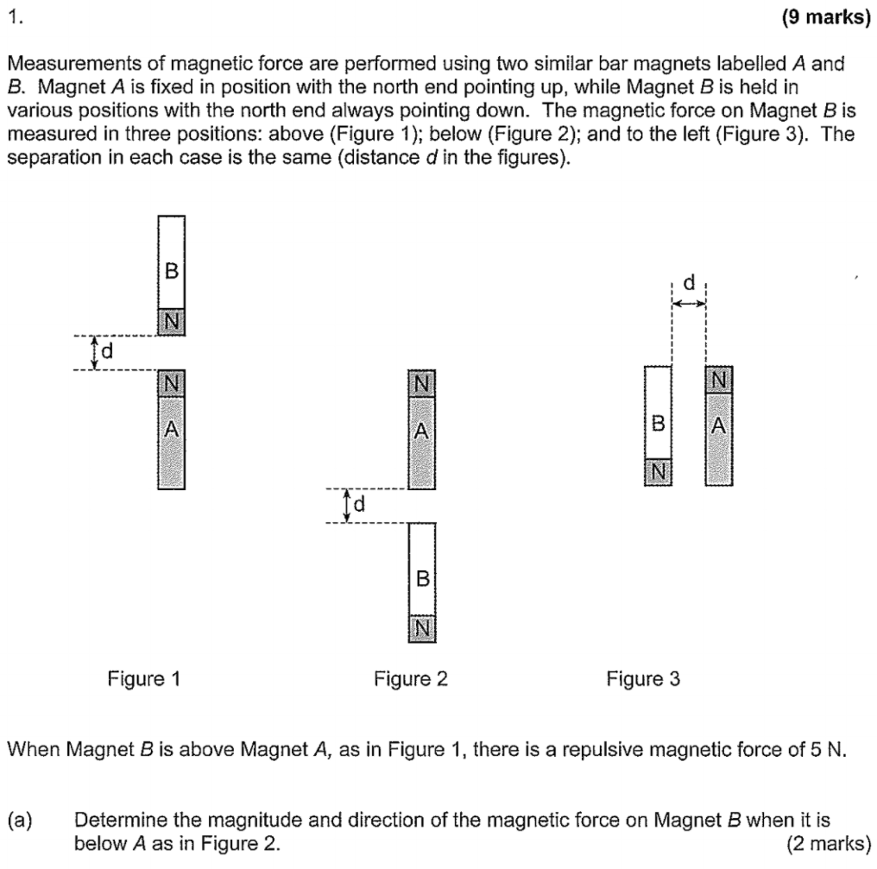

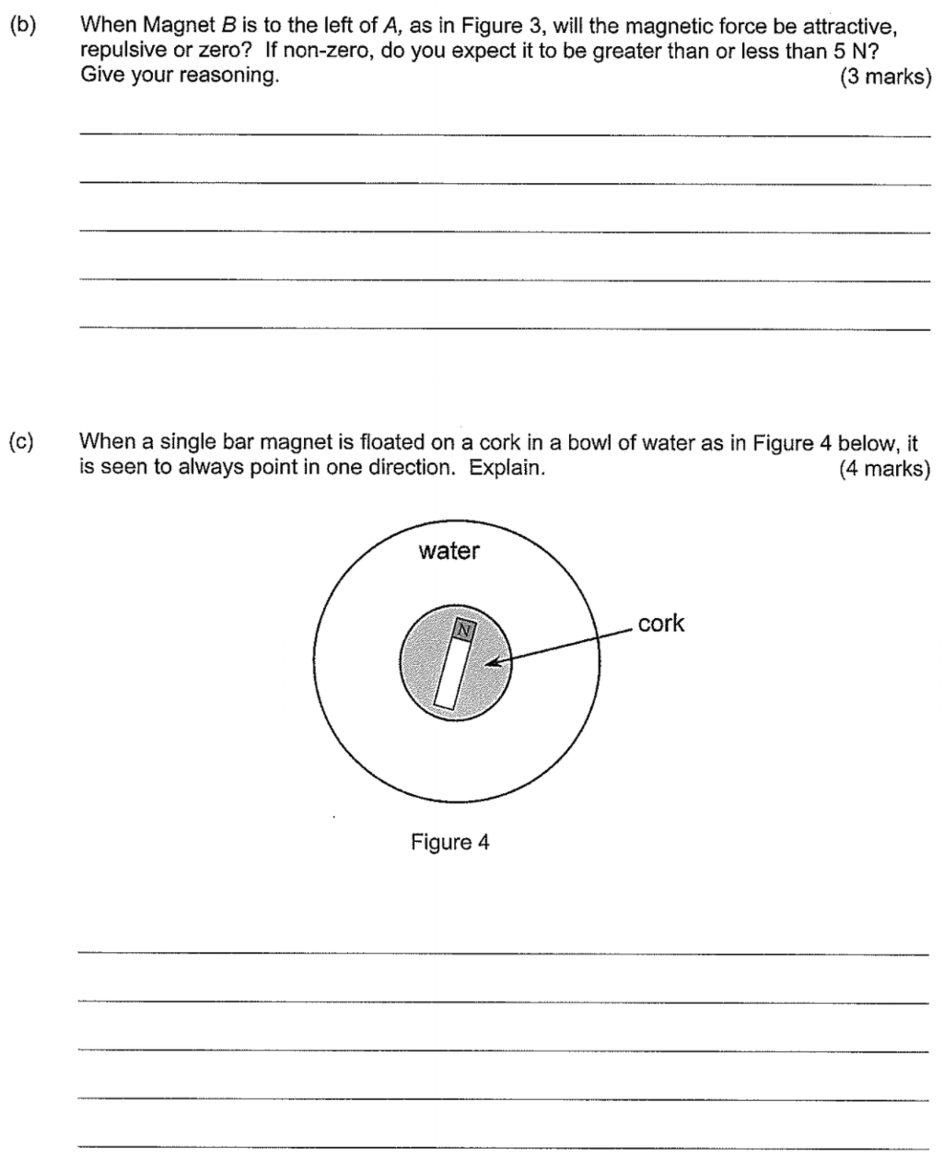

Part [b]: Repulsive force of 5N.

Part [c]: The Earth’s north pole attracts the N of the magnet, exerting a torque on the magnet which causes it to rate and align its axis with the Earth’s magnetic field lines.

